LOCATION : NATIONWIDE
DATE : 02.02.2018
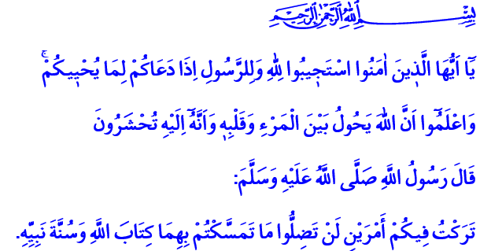
THE TWO MAIN SOURCES OF ISLAM:
THE QUR’AN AND THE SUNNAH
Jumu’ah Mubarak, Honorable Believers!
Our Almighty Lord enjoins in the verse I have recited: “O you who have believed, respond to Allah and to the Messenger when he calls you to that which gives you life. And know that Allah intervenes between a man and his heart and that to Him you will be gathered.”
Our Prophet (s.a.w.) said in the hadith I have read: “I am leaving behind two things to you. As long as you hold to them tightly, you will not go astray. They are the Book of Allah and the Sunnah of His Prophet.”
Dear Brothers and Sisters!
The Holy Qur’an is the power and guide that constructs our world and our afterlife, our present and our future. Our Prophet’s Sunnah is where the Qur’an meets with life, and becomes comprehensible and practicable. Therefore, we have been learning the sure religion of Islam from these two main sources for fourteen centuries.
The Holy Qur’an commands us to believe in our Prophet besides the belief in Allah. It asks obedience to the Prophet right after obedience to Allah. Because our Prophet (s.a.w.) is the one who conveyed and taught our Holy Book to us. The Qur’an has been transformed into a lifestyle through his exemplary life. Those who organize their lives in the light of the Qur’an and in the unique leadership of our Prophet would never lose their direction.
Honorable Believers!
The Holy Qur’an, the Book of our purpose of existence, commands us to believe in Allah and be a servant only to Him. Our Prophet (s.a.w.) showed us the real faith as he did not bow before any power except Allah, and he displayed a dignified and honorable stance in all circumstances and situations.
The Holy Qur’an commands us prayers which keep our faith alive and bring us closer to Allah. And through his life, our Prophet taught us how to pray, how to fast, how to pay zakat, how to perform the pilgrimage and how to worship our Lord.
The Qur’an commands us to enjoin what is good and forbid what is evil, to defend the right and the truth, to be trustworthy, to have compassion and mercy, in short to become honored with morality. Our Prophet became an example to all of us about how to be a good believer by practicing these virtues.
Honorable Brothers and Sisters!
The history is our witness that we have always been attached to our Holy Book heartedly. We have felt a deep fondness towards the Messenger of Allah. We have been an honorable ummah and an example to humanity as long as we correctly understood and practiced the peaceful messages of the Holy Qur’an and the Sunnah of our Prophet. But when we became unable to reflect this devotion and fondness to our actions, when we strayed from the knowledge, wisdom, and determination that the Qur’an and the Prophet ask of us, then we lost our power and weakened. When we began to neglect the supreme spirit and ideals that the Qur’an and the Sunnah want us to achieve, then we got stuck in the swamp of ignorance.
Dear Muslims!
There is only one way for us to free ourselves from the pain and difficulties we have been suffering and once again become an ummah which offers peace, tranquility, and civilization to the humankind. This way is to hold tightly to the Qur’an and the Sunnah as the believers of our Holy Book and the ummah of our Beloved Prophet. It is to make no concessions from these two sources in learning and practicing our religion correctly. It is to be aware of those who try to put a wedge between the Qur’an and the Sunnah, and those who try to obtain power and interest by abusing these most sacred values of ours. It is to make efforts to raise generations who look at the world through the last Book of Allah and the pure Sunnah of the Prophet, who are devoted to their religion and nation with a sense of loyalty.
Esteemed Brothers and Sisters!
It is our duty to raise and educate our children with the sense of faith, the love of prayer and the consciousness of morality which are fed by the Qur’an and the Sunnah. It is our goal to ensure that they become good persons and exemplary believers. I would like to remind you esteemed believers an important issue that could serve this goal: As you know, The Holy Qur’an, The Life of Our Prophet and Basic Religious Knowledge are given as selective courses in our schools. We should be attentive to ensure our children to select these courses. Let us not forget that our beloved children are entrusted to us by our Lord and it is our responsibility to raise them to live in accordance with the consent of Allah. May our Almighty Lord make our children dutiful towards their parents and beneficial to their religion, nation and the humanity.

Anfal, 8/24.
Muwatta Malik, The Decree, 3. Issued by: General Directorate of Religious Services

