LOCATION : NATIONWIDE
DATE : 15.09.2017
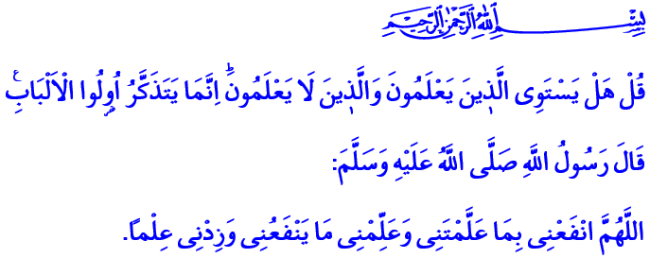
ARE THOSE WHO KNOW EQUAL WITH THOSE WHO KNOW NOT?
Honorable Believers!
One day, some companions of the Prophet in the Al-Masjid an-Nabawi were busy praying, and another group were busy studying. Our Prophet (pbuh) observed this situation and said: “Both groups are busy with a good endeavor. Some pray to Allah and ask Him for certain things. Allah will give or will not give them if He wishes so. The others study and teach that knowledge to those who do not know. What they are doing is more virtuous.”
Messenger of Allah (pbuh) did not just gratify his companions who sought knowledge. He said: “Indeed, I have been sent as a teacher, an educator.” and sat beside them. Because he was a prophet who showed the superiority of knowledge with the life he led in the light of this verse: “Are those who know equal with those who know not?”
Brothers and Sisters!
Our Prophet placed great importance to education and knowledge throughout his life. Eradicating ignorance was a very important goal for him. The way to truth and God was to teach knowledge which gives meaning to life and honor to humans. He was a Messenger of Mercy who prayed “O Allah, teach me that which will benefit me, and increase me in knowledge.” Because our Prophet was first addressed with the command “Read” in Holy Quran, our guide to the true path. Our Lord Almighty ordered the mankind through His Last Messenger: “Read! In the Name of your Lord, Who has created (all that exists), has created man from a clot. Read! And your Lord is the Most Generous, Who has taught (the writing) by the pen, has taught man that which he knew not.”
Honorable Brothers and Sisters!
We are the members of a civilization where knowledge is merged with reason and kneaded with wisdom, and the scholar is adorned with morals. Knowledge is considered as the prayer of the mind in our civilization. Knowledge means first and foremost to try to understand the truth and essence of objects, the purpose and reason of existence. Knowledge means to know oneself. Because those who know themselves know their Lord. Those who know their Lord sets learning the truth and essence of objects as their goal. Those who are conscious of their existence will be conscious of their environment, the universe and life.
Written by: General Directorate of Religious Services
Knowledge should not move a person away from himself, his Lord and people. It should not estrange him to his environment. Knowledge should lead a person to wisdom. It should address his heart, his soul. Knowledge should manifest itself in life with a sense of morality and responsibility. It should be seen as a means of gaining Allah’s countenance.
Brothers and Sisters!
Just as we are obligated to read the book of Allah and practice it in our lives, we are also obligated to read and understand the universe and the order in it. We have a responsibility to acquire all kinds of knowledge that benefits humans and humanity. We should never see knowledge as a means of satisfaction and self-interest. We cannot acquire knowledge to harm humanity, destroy the earth and make it uninhabitable.
Honorable Believers!
Our children, our youth are going to start a new education period. Our teachers will continue to raise generations who have conscience and compassion, who are committed to their values, who work for the benefit of their nation and humanity. I would like to take this opportunity to ask Allah Almighty for this education year to bring goodness to our teachers, our families, our nation and our children, who are the safeguards of our future. May our Lord grant our children knowledge which will allow them to achieve His countenance, and which our children will use for the benefit of the realm of Islam and all mankind.
I also would like to remind something to the parents. Let us not neglect our responsibility for our children to meet with the Quran’s climate of mercy and learn the exemplary life of our Prophet (pbuh). Let us guide our children to select Quran and Prophet’s life, which are taught as elective courses in our schools.
Dear Brothers and Sisters!
I want to share two things with you before I finish the khutba. Next Thursday we are going to observe the first day of the Islamic new year. I congratulate your new year in advance.
Also our Presidency have started an aid campaign with Turkey Diyanet Foundation for our brothers and sisters in Rakhine. In this campaign, today we are going to appeal to our noble nation in all mosques throughout the country. The collected donations will be delivered to our oppressed and innocent brothers and sisters in Rakhine to provide them some relief. May our Lord Almighty accept your charity and goodness. May He protect our country and noble nation who are the hope of the oppressed and helpless.

Ad-Darimi Muqaddimah, 32.
Az-Zumer, 39/9.
At-Tirmidhi, Chapters on Supplication, 128.
Al-Alak, 96/1-5.

