LOCATION : NATIONWIDE
DATE : 01.09.2017
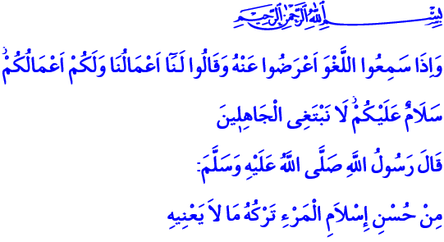
THE MANIFESTATION OF FAITH AND ISLAM: REFRAINING FROM FRIVOLOUS THINGS
Honorable Brothers and Sisters! A Blessed Friday and Eid to you all.
Praise be to our Lord Almighty who granted us Muslims the joy of this Eid and let us reach this holy Eid, this Friday. Salutations and peace be to our Prophet who taught us the faith, Islam, prayers and morals, thanks and praise.
Brothers and Sisters!
Our Lord Almighty says in the verse I have recited: “And when they hear vain talk, they turn away therefrom and say: Unto us shall be accounted our deeds, and unto you, your deeds. Peace be to you - (but) we seek not the ignorant.”
Our Prophet (pbuh) says in the hadith I have recited: “Surely, of the excellence of a person's Islam is that he leaves what does not concern him.”
Brothers and Sisters!
Today is a great day where we observe two feasts at once. Today is the day of joy which our Lord gifted us to allow us to unite and socialize, and to let our brothers feel our compassion towards them. Today is a bountiful and blessed day where talbiyahs are mixed with takbeers, prayers and invocations.
Honorable Believers!
Eids are not just days of joy, merriness and vacation. Eids are also days that give meaning to a believer’s life and get him closer to his Lord and his brothers. These are the days where peace and happiness are multiplied among Muslims through sharing and sadness and sorrow are decreased through helping each other. We, as Muslims, are going to observe this Eid with this mindset. We will try to live each moment of our lives and this Eid with words and behaviors that our Lord would approve. Because a believer is a person who refrains from words, attitudes and behaviors that are of no help to himself, his kith and kin or humanity.
Brothers and Sisters!
To believe is to take responsibility. In this sense, each blessing that is given to us demands a praise. Each opportunity that is granted to us brings a responsibility with it. Utilizing and protecting these opportunities and resources in the way of our Lord’s countenance and for the good of humanity is the most important responsibility that we have.
In this context, our tongue should not turn to lies but to truth. Our words should not articulate falsehood but truth. Our eyes should not seek sedition and malice, but amelioration and peace. Our hands should always reach for the good, not the bad. Our minds should give off goodness and beauty around us, not evilness and ugliness. Our hearts should not spread hatred and grudge but love and affection.
Brothers and Sisters!
The Messenger of Allah (pbuh) said: “The feet of the son of Adam shall not move from before his Lord on the Day of Judgement, until he is asked about five things: about his life and what he did with it, about his youth and what he wore it out in, about his wealth and how he earned it and spent it upon, and what he did with what he knew.”
Venerable Muslims!
As one can understand from this hadith, we are all heading towards a day of judgement with speed. Our only capital in this journey is our life, so precious that we couldn’t afford to waste a second of it. Our biggest strength in this journey is our faith and submission to Allah. Our earnings are our good deeds and actions. To waste all of this, to spend them all in vain would be our biggest loss and defeat.
Our task in this journey of life is to refrain from frivolous words, attitudes and behaviors. Because frivolous words and behaviors keep our minds needlessly busy, damage our reputation and character, and over time, make us their prisoners. Occupations that do not help us in this world and hereafter will not bring us goodness, blessings and kindness. Just the opposite, it will kill our time and consume our life.
Brothers and Sisters!
Nowadays, some frivolous and time consuming tv shows, web-sites and games have nearly created an industry of uselessness. Such occupations that add no benefit to this world and hereafter drives a person away from himself, his environment and his Lord. They alienate him to his brothers. But a Muslim only feels the blessing of time when he turns towards good deeds that are useful for both realms. A Muslim will become honorable and be respected to the extent that he displays words, attitudes and behaviors worthy of his humanity.
Honorable Brothers and Sisters!
I want to conclude the khutba with this prayer that our Prophet (pbuh) taught us: “O Allah! I seek refuge in You from the evil of my hearing; the evil of my sight; the evil of my tongue; and from the evil of my heart” O Lord! Protect us from all these!

Al-Qasas, 28/55.
At-Tirmidhi, Chapters on Zuhd, 11.
At-Tirmidhi, Chapters on the description of the Day of Judgement, Ar-Riqaq, and Al-Wara', 1.
Sahih al-Jami No. 1303. Written by: General Directorate of Religious Services

