LOCATION : NATIONWIDE
DATE : 29.09.2017
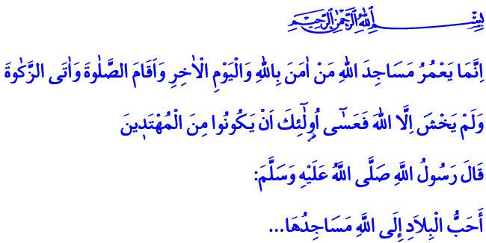
THE MOSQUE, THE CITY
AND THE CIVILIZATION
Blessed Friday to You, Brothers and Sisters!
Please come! Let us remember the day of Asurah, which we are going to observe tomorrow, and Karbala, which has drowned us in sorrow for centuries. Let us remember Husain, one of the two distinguished grandchildren of Allah’s Messenger, the dearest to the believers, the master of the martyrs and the young in heaven. Let us send prayers and salutations to the Greatest Messenger and his people of the house.
Brothers and Sisters!
Please come! Let us also remember in today’s khutba the mosque and the Mosques and Religious Officials Week, which we have been celebrating for nearly a quarter century. Let’s seek the ways of placing the mosques at the center of the city and our lives, and turn them into cradles of civilization again. Let us consider once again how important the mosques are in our lives.
Honorable Brothers and Sisters!
Our Lord Almighty says in the verse I have recited at the beginning of this khutba: “The Mosques of Allah shall be maintained only by those who believe in Allah and the Last Day; perform As-Salat (Iqamat-as-Salat), and give Zakat and fear none but Allah. It is they who are expected to be on true guidance.”
Our Prophet (pbuh) says in the hadith I have recited at the beginning of this khutba: “The parts of land dearest to Allah are its mosques.”
Honorable Believers!
Mosques are the heart of the Islamic civilization. In our civilization, not having a mosque or a place of worship in a city is unthinkable. When our Prophet (pbuh) arrived in Medina, he immediately built the Al-Masjid an-Nabawi (Prophet’s Mosque) in the heart of Medina with the help of his companions. Al-Masjid an-Nabawi became the center of Madina and the cradle of civilization. Values such as science, knowledge, morality, justice, love, respect, compassion and mercy spread from this blessed place like waves across the world. From that day until today, the Islamic cities have been built and shaped around the mosques. In short, the mosque has been the soul of the city.
Dear Brothers and Sisters!
The mosque is life for us believers. For in the mosques, we feel very deeply the pleasure of bowing before Allah and being a servant only to Him. The mosques pull us away from the endless bustle of life, their spiritual climate gives us a new awareness and put us back. They educate us by patiently working on our emotions and thoughts. For this reason, the mosques are the places of knowledge, wisdom, and morality for us always. They are the schools where we learn Our Lord, Our Religion, Our Book, Our Prophet, brotherhood, and life.
Mosques are the places that unite our hearts in the presence of the Most Beneficent. The mosques are built so that we’d carry the sense of unity we feel in the mosques when we stand together in rows and when we bow together in ruku and sajdah to our society. Mosques are built so that we’d carry the conscience of “the trustworthy believers” to whom people trust that no harm will come from them, and the conscience of “role model” that people admire to our homes, neighborhoods, our country and all humanity.
Venerable Brothers and Sisters!
The mosques are symbols of independence for Islamic cities. They are the symbols of tawhid (oneness) with their minarets. They are the expression of martyrdom with their adhans. They are the centers that could revive and raise a nation with their salas. They are the places of knowledge, wisdom and attainment with their minbars. They are the voices of the right and the truth with their pulpits. Their mihrabs are the places of battle against all kinds of evil such as anger, grudge, hatred, and sins that try to conquer our hearts.
Dear Brothers and Sisters!
The Presidency of Religious Affairs has set the theme of the Mosques and Religious Officials Week this year as “The Mosque, The City and The Civilization”. During the week, the importance of the mosque in the revival of a believer, the soul of a city and the birth of a civilization will be emphasized through various programs. We will be reminded that restoring the mosques to their state in the Age of Bliss is a task for all believers.
I wish that the Mosques and Religious Officials Week will bring blessings. I wish for health and peace for the brothers and sisters who served the mosques, and I ask mercy from our Lord for those who passed away. May our Lord let our hearts, minds and bodies embrace the mosques. May our Lord never deprive us of the adhans, as their witnessing is the foundation of religion.

At-Tawbah, 9/18.
Sahih Muslim, The Book of Mosques and Places of Prayer, 288. Written by: General Directorate of Religious Services

