LOCATION : NATIONWIDE
DATE : 08.09.2017
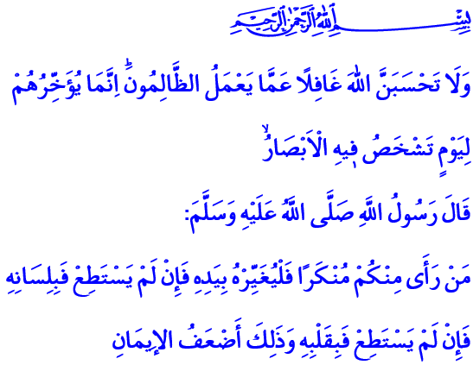

TO STAND BY THE OPPRESSED
Blessed Friday to You All, Honorable Muslims!
Our Lord Almighty says in the verse I have recited: “Do not think that Allah is unaware of what the evildoers are doing: He but grants them respite until the Day when their eyes will stare in horror.”
And our Prophet (pbuh) says in the hadith I have recited: “He who amongst you sees something abominable should modify it with the help of his hand; and if he has not strength enough to do it, then he should do it with his tongue, and if he has not strength enough to do it, (even) then he should (abhor it) from his heart, and that is the least of faith.”
Dear Brothers and Sisters!
Unfortunately, the whole Islamic world observed a sorrowful eid once again. Our hearts were sad, our eyes were tearful. We could not feel the joy of eid deep in our hearts. We couldn’t exactly live the spiritual atmosphere of the Hajj. We couldn’t fully experience the excitement of the sacrifice. Because as the futile conflicts, violence and fights in the Islamic geography continues to sadden us; the oppression, violence and massacre that our brothers and sisters in Rakhine are facing tear our hearts out. The cries of the oppressed and innocent from these faraway lands hurt us deeply.
Honorable Brothers and Sisters!
The injustice, false accusations, violence and oppression Muslims are subjected today shocks us all. But what’s worse is the indifference of a big portion of humanity against this situation; the silence of those organizations established to prevent oppression, evil and injustice in the world; the fact that the world is blind and deaf against the earth-shattering cries of the oppressed and the innocent; the fact that the tiny corpses of those washed ashore are ignored while a beached whale makes the news; the loss of mercy and conscience as people are starving to death and as children, women and the elderly are being deported from their homes; the fact that different groups turn a blind eye to the massacres that Muslims face.
Honorable Believers!
Our holy religion considers the murder of a person same as the murder of all humanity. Because our faith teaches us that each human is inherently valuable. A human is worthy because he or she is a sign of Allah. Each person has the right to life, faith, property and dignity. No one could be denied his basic rights and freedoms, or deported from their homeland, or subjected to violence and savagery because of his faith. In our faith, one cannot keep silent against any oppression, let alone perpetrate it. One cannot take the side of the oppressor and turn his back on the oppressed no matter what. Our guiding principle in this matter is this warning of our Prophet (pbuh): “When the people see a wrongdoer and do not prevent him, Allah will soon punish them all.”
Esteemed Brothers and Sisters!
We believers cannot give way to despair. We believe that oppressors will get the punishment they deserve, sooner or later. We know that all these unfortunate events will certainly come to an end. As long as we, as the descendants of a nation which became the hope of humanity throughout history, extend our hands to the oppressed and the innocent with a spirit of unity. Let us stand against the oppressors and stand by the oppressed as we did in the past, regardless of their religion, color and geography. Let us stand against every form of oppression even if we are alone, with the belief that our Lord is our greatest helper. Let us always defend the right and the righteous even when the axis of evil come down on us with all its might, knowing that the prayers of the oppressed is our greatest power. Let us never keep silent against injustice. 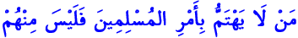 “The one who does not care about the Muslims is not one of them” . Let us take this hadith to heart and protect our brotherhood. Let us share our joy and sadness, our wealth and poverty with our brothers and sisters.
Honorable Believers!
Let us sincerely pray to our Lord Almighty in this time of Friday: O Allah! Treat our brothers and sisters who struggle for their existence in different parts of the world with your help and mercy! Grant them salvation from hardship! O Allah! Rest the souls of our brothers and sisters who lost their lives in the massacres in Rakhine and other parts of the world! Grant quick recovery for the wounded! O Allah! Help our honorable nation, as they are the conscience of humanity! Grant foresight, insight, peace and tranquility to the realm of Islam and all humanity. O Allah! Let us be those who live humanely, not those who forgot their humanity!

Al-Ibrahim, 14/42.
Sahih Muslim, The Book of Faith, 78.
Abu Dawud, Battles, 17.
by al-Tabarani in al-Mu’jam al-Sagheer, II, 131. Written by: General Directorate of Religious Services

