LOCATION : NATIONWIDE
DATE : 24.02.2017
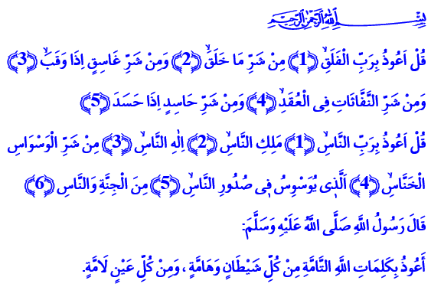
BEST DESCRIPTION OF REFUGE IN ALLAH: SURAH AL-MU'AWWIDHATAN
Honorable Believers!
The Almighty enjoins in the surahs Al-Falaq and An-Nas that I have recited at the beginning of my khutbah: “Say, ‘I seek refuge in the Lord of daybreak from the evil of that which He created and from the evil of darkness when it settles and from the evil of the blowers in knots and from the evil of an envier when he envies.’”
“Say, ‘I seek refuge in the Lord of mankind, the Sovereign of mankind, the God of mankind from the evil of the retreating whisperer who whispers evil into the breasts of mankind from among the jinn and mankind.’”
Brothers and Sisters!
The biggest danger for a person in the world is to forget the purpose of their creation. To veer away from the path. The greatest loss for a person is to lose themselves. To be a slave to desires. The biggest deprivation for a person is to deprive themselves of seeking shelter in the vast grace of Allah.
Our Almighty Lord sent us a Noble Book full of life that will protect us from the aforementioned dangers and save us from suffering losses and damages. He showed us the ways to be servants to Him in the best way. He taught us how to live under his shelter particularly in the two powerful surahs called Al-Falaq and An-Nas in our Holy Book. That’s why the Prophet (pbuh) recommended us to frequently recite these two surahs which he considered the best description of refuge in Allah.
Dear Brothers and Sisters!
Al-Falaq and An-Nas surahs are a concise description of our belief of oneness and our submission to Allah. They are the indication of our commitment to live by seeking His favor and protection. By reciting Al-Falaq and An-Nas, we seek refuge in Allah from all evil and from losing our path amid darkness. We seek His shelter from hatred, enmity, jealousy, hate, superstition, and delusion. We ask for His help against the evil of the malevolent, the evil-eyed, the stone-hearted, the unconscionable. We ask for His assistance and mercy against those who sow seeds of discord and sedition and who exploit thoughts and sentiments. We know that our Lord is the only shelter where we will feel safe.
Brothers and Sisters!
Al-Falaq and An-Nas always advise us a believer’s attitude, a conscious life. Because we must seek Allah’s refuge not only in times of difficulty and hardship but also in wealth, joy, and strength. Contemplating His power is our mind’s refuge. Sincerely seeking His mercy, forgiveness, and grace is our heart’s refuge. Putting His might into words as we like is our tongue’s refuge. And when the mind, the heart, and the tongue seek His shelter, the whole body must join them. Because what really makes us valuable in the eyes of our Lord is our good deeds.
Brothers and Sisters!
Al-Falaq and An-Nas teach us to be sagacious and heedful against those who want to exploit our faith, our sentiments, our desperation. They teach us to be servants to Allah alone and not to any mortal being. Because who else do we have other than our Lord who never abandons us even when everyone else does? Isn’t He the One who sees us even when nobody does, hearts us even when nobody does, and on whom we can always rely? Does He ever turn down the prayers, the heartfelt supplications? Does He ever deprive and aggrieve those who seek His shelter and knock on His door of grace? All we need to do is turn our hearts towards Him sincerely. Let our tongues dearly glorify Him and supplicate to Him. Let our hands turn to Him heartily and ask from Him alone.
Dear Brothers and Sisters!
I would like to conclude my khutbah with the prayers of refuge our Prophet (pbuh) taught us:
“We seek refuge in Allah’s exact words, His eternal will and judgement from all evil and malice and doers of evil.”
“O Allah! We seek refuge in You from the evil of our ears, the evil of our eyes, the evil of our tongues, the evil of our hearts, the evil of our desires.”
“O Allah! We seek refuge in You from incapability, from laziness, from stinginess, from cowardice, and from the trials and tribulations of the grave.”

Al-Falaq, 113/1-5
An-Nas, 114/1-6.
An-Nasa’i, İstiâze, 1; Al-Darimi, Fezâilü’l-Kur’ân, 25.
Bukhari, Ehâdîsü’l-enbiyâ, 10.
Tirmidhi, Deavât, 74.
Muslim, Zikir, 73. Written by: General Directorate of Religious Services

