LOCATION : NATIONWIDE
DATE : 20.01.2017
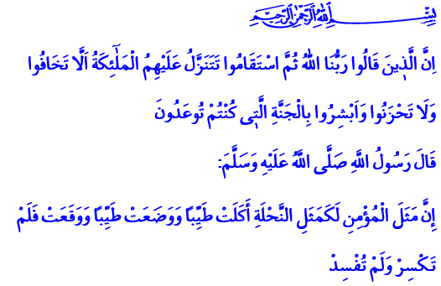
FAITHFUL SERVANTS OF THE COMPASSIONATE
Honorable Brothers and Sisters!
In the verse I have recited, Allah Almighty enjoins: “Indeed, those who have said, ‘Our Lord is Allah’ and then remained on a right course; the angels will descend upon them saying, ‘Do not fear and do not grieve but receive good tidings of Paradise, which you were promised.’”
In the verse I have recited, the Prophet (pbuh) says: “A believer is like a honeybee. He always eats good, clean, lawful things like the bee. He always produces good things, always purses goodness. He never breaks or ruin anything.”
Honorable Believers!
The Almighty sent down a Holy Book for us. He sent down an exemplary Prophet for us. He taught us how to lead a humane life, how to have a believer’s attitude with examples from His Book and His Messenger. Let us remember once again in today’s khutbah the qualities of a believer as described by the Holy Quran and demonstrated by the Prophet’s exemplary life.
Brothers and Sisters!
The believer is one who sincerely believes in the existence and oneness of Allah. They unwaveringly acknowledge Allah’s angels, books, prophets; the afterlife, destiny, and what Muhammad Mustafa (pbuh) brought from the ranks of Allah. The believer is the person who turns the Prophet’s exemplary morality into a life.
Brothers and Sisters!
The believers presented to us in the Quran are those cognizant of the purpose and wisdom in their creation. They think, remember, and reflect upon what they see, hear, and experience. They live with the awareness of being servants and worshipping. They perform their prayers with conscious and in submission and consider them ascension. They give charity merely for Allah’s sake from the heart. They make their fast a shield against evil.
Believers are true servants of the Compassionate. Their hearts are satisfied with the remembrance of and gratitude to Allah. They feel a heartfelt, deep respect when His name is mentioned. They are not deaf or blind to the verses, commandments, and bans of Allah. They strive to understand them all accurately and implement them in the best way.
Dear Brothers and Sisters!
Believers are humble. They do not get arrogant. They do not brag. They do not act superior. They are dignified. They stand clear of empty words, acts, and attitude that are of no use to their world and afterlife. When the ignorant pick on them, they merely respond by saying, “peace!”
Believers have trust. They only rely on Allah. They only seek His help. They repent for their faults and sins. They recognize their mistakes and do not persist on them. They always act with patience. They do not give up in the face of hardship and calamity, they do not lose hope. They know life is a test and say اِنَّا لِلّٰهِ وَاِنَّٓا اِلَيْهِ رَاجِعُونَۜ “To Allah we belong and to Him we shall return,” thereby uttering their submission and fortitude. They overcome anger. They forgive the bad things done to them.
Honorable Brothers and Sisters!
Believers adopt righteousness and loyalty as motto. They avoid lies, false testimony, and deception. They never break their word. They never misappropriate. They do not veer away from what is true and just. They preserve their dignity and honor. They do not shy away for one second from fighting for a humane life. They do not hang back from sacrificing in Allah’s cause in poverty and in wealth.
Believers are friends and brothers to one another. They do not abandon each other to loneliness. They do not wish bad things for others. They compete in goodness, not evil. They help one another in goodness, not in sin. They value mercy and compassion. They do not allow oppression, violence, and savagery. They do not cast a shadow upon each other’s prestige, they do not cross lines. They never abandon moderation. They do not break the heart that Allah looks at. They especially do not take a life deemed venerable and forbidden by Allah.
Honorable Brothers and Sisters!
All of these are the qualities of our Lord’s faithful servants that He described in His Book. Those who possess these good qualities have neither fear nor sorrow. They will attain Allah’s infinite grace and eternal paradise. There, they will be greeted with respect and peace. They will be entertained with the nicest of treats.
Fortunate are the true servants of the Compassionate! Fortunate are those who have earned Allah’s favor by living in compliance with the purpose and wisdom of their creation! Fortunate are those who have taken the path of peace! Fortunate are those who have turned the mortal world into an immortal gain!
May the Almighty grant us to be among the servants He likes and favors.

Fussilat, 41/30.
Ibn Hanbal, II, 199; Hâkim, Müstedrek, I, 110. Written by: General Directorate of Religious Services

