LOCATION : GENEL
DATE : 03.03.2017
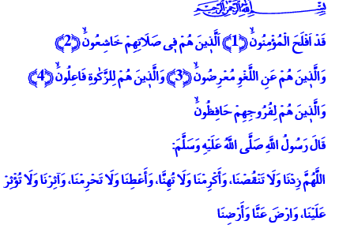 INHERITING AL-FIRDAWS
Honorable Believers!
As narrated by Umar, a revelation came to Allah’s Messenger (pbuh). He waited for a while then turned to qibla. He raised his hands and supplicated to His Lord: “O Allah! Increase Your blessings, don’t decrease them! Give us honor, not misery! Help us reach our goals, don’t spare them from us! Grant us to be among those who You favor and who favor You!”
Brothers and Sisters!
After this prayer, the Prophet said, “Ten verses have been revealed to me just now. Whoever implements the tenets in these verses gets into paradise,” and recited the first ten verses of Surah al-Mu’minun.
In today’s khutbah, I’d like to share with you those ten verses that will make us the inheritors of the highest gardens of paradise. Let us find out the true believers mentioned in the ten verses who attain salvation.
اَلَّذ۪ينَ هُمْ ف۪ي صَلَاتِهِمْ خَاشِعُونَۙ They are humbly submissive during prayer. They consider prayer a moment of union with the Lord, a longingly awaited meeting. They do not reduce this magnificent worship to mere form. They never waste its spirit.
وَالَّذ۪ينَ هُمْ عَنِ اللَّغْوِ مُعْرِضُونَۙ They stay clear of ill speech and acts that are of no use to their world and hereafter. Because life is too short and precious a blessing to even waste a second. Time is a unique treasure we have been entrusted. And one day, the Almighty will hold us accountable for everything.

وَالَّذ۪ينَ هُمْ لِلزَّكٰوةِ فَاعِلُونَۙ The believers who have attained salvation are those who give alms. They do charity. They practically compete one another in charity. And alms is the right of the poor and needy in the wealth of the rich. It protects a person against being the slave of wealth, fortune, and power. It saves one from material burdens. It cleans one from sin and filth on the other hand.
Brothers and Sisters!
The believers who have been promised paradise,
وَالَّذ۪ينَ هُمْ لِفُرُوجِهِمْ حَافِظُونَۙ are those who keep their dignity. Because one keeps their character intact as long as they protect their clean disposition and honor. They are treated with respect as long as they do not hurt anyone’s dignity.
وَالَّذ۪ينَ هُمْ لِاَمَانَاتِهِمْ وَعَهْدِهِمْ رَاعُونَۙ They protect what they have been entrusted. They keep their word and promise. Because being loyal and trustworthy is one of the most important characters for a believer. For a believer is the follower of the path of Muhammad the Trustworthy, the trustworthy prophet.
وَالَّذ۪ينَ هُمْ عَلٰى صَلَوَاتِهِمْ يُحَافِظُونَ The believers who will get into al-Firdaws carefully maintain their prayers. They are those who are protected by prayer against bad things. It is a fact that prayers protect us if we protect them. They are a shield for us against all evil if we hold dear and love the prayers.
Brothers and Sisters!
The Almighty’s great reward is for those believers mentioned here. اَلَّذ۪ينَ يَرِثُونَ الْفِرْدَوْسَۜ هُمْ ف۪يهَا خَالِدُونَ They are the eternal inheritors of al-Firdaws which is one of the most special places in paradise. It is one of the highest ranks. It is the part of paradise that was a reason for consolation and mourning to mother Fatimah who said “O father who is placed in al-Firdaws!” after the Prophet’s (pbuh) passing.
Brothers and Sisters!
May the Lord Almighty grant us to be among the blissful believers who attain salvation and become neighbors to our Prophet (pbuh) in al-Firdaws.

Al-Mu’minun, 23/1-10.
Ibn Hanbal, I, 351; Tirmidhi, Tefsir, 24.
Bukhari, Megazi, 78. Written by: General Directorate of Religious Services

