LOCATION : GENERAL
DATE : 30.06.2017
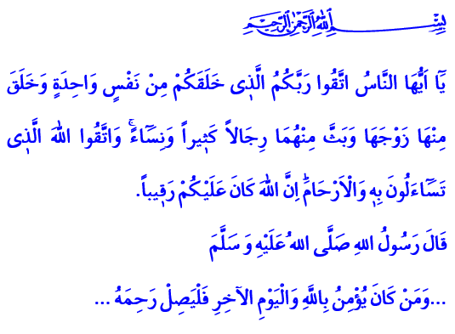
THE BOND ALLAH WANTS US TO MAINTAIN: FAMILY TIES
A Blessed Friday to You, Brothers and Sisters!
In the verse I have recited, Allah Almighty enjoins: “…Be careful of (your duty to) Allah, by Whom you demand one of another (your rights), and (to) the ties of relationship; surely Allah ever watches over you.”
In the hadith I have recited, our Prophet (pbuh) says: “…Whoever believes in Allah and the Last Day should keep good relation with their kin…”
Venerable Muslims!
A companions one day told the Prophet: “O Allah’s Messenger! I try to keep in touch with my relatives, but they do not. I do them favors, they do me wrong. I treat them with kindness, they treat me rudely.” Then, the Messenger of Allah (pbuh) told the companion that Allah’s assistance was going to be with him as long as he kept treating his relatives nice no matter what.
Honorable Believers!
Maintaining the bond of kinship is a crucial occasion to keep our ties with our family, our relatives, and our neighbors. It means taking care of relatives. Sharing their joy and grief. Being a safe harbor for one another. Coming to the rescue of our close ones when they are in difficulty. Taking their hand and lifting them up when they fall. Refreshing our mind and spirit, exhausted in the various ruckus of the world, with the compassion, mercy, and fondness of one another.
Brothers and Sisters!
It is a path to attain Allah’s grace to look after all our relatives, especially our parents. Allah enjoins in a hadith through His Messenger: “I am the Merciful. I have created ties of kinship and derived a name for it from My Name. If anyone maintains ties of kinship, I maintain connection with him, and I shall cut off anyone who cuts them off.”
Honorable Brothers and Sisters!
In this world, we are all away from home. And the feeling of homesickness gets easier with a helping hand we extend to each other. The joy of reunion reduces the hardship of being away from home. If we treat each other with kindness and affection in this world where we are homesick, Allah will treat us with His mercy on the Day of Reckoning. If we offer compassion, mercy, and sincerity to one another here, Allah will grant us with unending blessings of paradise in the hereafter which is our eternal home.
Brothers and Sisters!
Then come! Let us care about maintaining the ties of kinship which is one of the conditions of earning Allah’s favor. Let us please our parents, spouses, and children at all times. Let us keep in touch with our close/distant relatives and neighbors. Let us not abandon our close ones to the coldness of homesickness as they are all precious to us. Let us avoid building walls between our hearts without realizing amidst the hustle of life. Let us take these days we spend in the shadow of Ramadan and Eid as an opportunity to make distances closer to us.
Let us always remember that the real way of maintaining ties of kinship is being able to get in contact with someone who does not keep in touch with you. It is being able to call those who do not call you. Visiting those who do not visit you. Because real dignity is not doing favors to those who have done favors to us, it is doing favors to those who have not.
Honorable Brothers and Sisters!
May Allah Almighty grant us to be among those who recognize the importance of maintaining the ties of kinship and who abide by family ties.

An-Nisa, 4/1.
Bukhari, Edeb, 85.
Muslim, Birr, 22.
Abu Dawud, Zekât, 45.
Bukhari, Edeb, 15. Written by: General Directorate of Religious Services

