LOCATION : NATIONWIDE
DATE : 28.04.2017

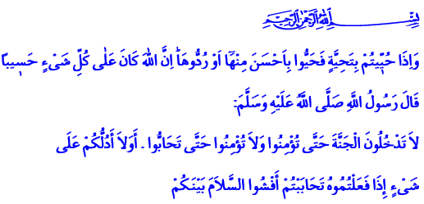

THE BRIDGE OF TRUST AND LOVE: GREETING
Salutations to souls that believe Allah and His Messenger!
A blessed Friday to you, honorable Brothers and Sisters!
In the verse I have recited, the Almighty enjoins: “And when you are greeted with a greeting, greet in return with one better than it or at least return it. Indeed, Allah takes careful account of all things.”
In the hadith I have recited, our Prophet (pbuh) says: “You shall not enter Paradise so long as you do not affirm belief! And you will not believe as long as you do not love one another! Should I not direct you to a thing which, if you do, will foster love amongst you: Give currency to greeting one another!”
Brothers and Sisters!
One of the names of the Almighty Lord is “As-Salam.” He is the source of peace and prosperity. That’s why we utter His name “Salam” after every prayer. We say: “Allahumma antas salam wa minkas salam tabrakta Ya dhal Jalali wal ikram!” It means: “O Allah, You are peace; peace, safety, and security comes from You. Blessed are You O Possessor of Glory and Honor!” We pray to our Lord that he may guide us to salvation and the true path, and let us live in peace and safety.
Honorable Brothers and Sisters!
Greeting is a symbol of the believer. It is the name of quiet and safety, being far away from fear, concern, worry, and danger. For that reason, we greet all believers we know or not, and we form bonds of trust and love. We say “salam alaykum” or “may Allah’s peace be upon you” when we begin talking, and show our goodwill in prayer
Greeting is the assurance we give to others that we are their friends and no harm will come from us. It is the oath of remaining brothers and forgetting about grievances and hatred. Because a greeting accompanied with a smile wipes away concerns and grievances. It unites the hearts, leads to compassion and kindness.
Brothers and Sisters!
Greeting is not an ordinary gesture, it’s not a daily habit. It is a precious key that opens locked doors and mends hearts. That’s why when the Prophet (pbuh) reached Medina after his Hijrah journey, he said this to the crowd that welcomed him with jubilation: “O you people!” “Spread the greeting!” “Feed the needy!” “Keep in touch with relatives!” “Perform prayer while people are sleeping!” “And you will enter paradise in peace!”
Brothers and Sisters!
Our Graceful Prophet always greeted people during his lifetime. He greeted everyone – women, men, elderlies, and children alike. He said, “The person favored most by Allah is the one who initiates the greeting.” He even greeted the residents of the cemetery, and wished them well-being.
Well, brothers and sisters, if we have such a prophet, how can we pretend to not know our next door neighbors and pass by them? How can we spare the greeting from our relatives and close ones? How can we ignore the poor, the orphans, and the homeless who are entrusted to us? Remember that sparing Allah’s greeting is the worst type of stinginess. Those who worry that “If I greet him I will end up owing him something” must know that the believer ends up owing when he does not greet. Because our Prophet mentioned greeting among the rights of Muslims on other Muslims.
Honorable Believers!
The language of greeting is universal. Because our Lord’s name Salam has surrounded the whole realm. A person needs greeting regardless of their color, race, denomination, disposition. Time and distance cannot stop the wind of well-being. Greetings and prayers we send to fellow Muslims, the oppressed and victims find their destination just like every greeting we send from distant places to Medina and to our Prophet reaches him.
Honorable Brothers and Sisters!
May the Exalted make peace and safety prevail over our country, Islam’s cities, and the whole world. May He make it easy for us to turn our faith into peace and peace into safety. May Allah’s peace, grace, abundance, and prosperity be upon all of us.

An-Nisa, 4/86.
Muslim, İman, 93.
Tirmidhi, Sıfatü’l-Kıyâme, 42.
Abu Dawud, Edeb, 132-133.
Muslim, Selâm, 5. Written by: General Directorate of Religious Services

