LOCATION : NATIONWIDE
DATE : 20.10.2017
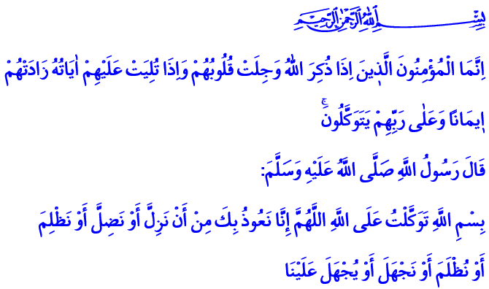
A FAITHFUL STANCE: TRUST IN ALLAH
Blessed Friday to You, Brothers and Sisters!
Our Prophet (pbuh) and Abu Bakr set out for the journey towards Madinah. The polytheists learned about this and began to look for them all over. Messenger of Allah and his companion took refuge in a cave in Mount Thawr to lose their trackers and confuse the polytheists. At some point, the polytheists came and stood in front of the cave. Abu Bakr expressed his concern by saying “O Messenger of Allah! If any of them should look under his feet, he would see us.” Always in complete trust and submission to Allah, our Prophet Muhammad said this to his friend to calm him as it is told in the verse, and in a way taught us to trust in Allah: “Do not grieve, for Allah is with us. What do you think of two (persons) the third of whom is Allah?”
Brothers and Sisters!
One of the most important qualities a believer should have is the trust in Allah. Putting our trust in Allah is to do our best first and leave the rest to Allah Almighty. Trust in Allah is to admit our inability and helplessness and submit ourselves to Allah without a question. It is to take refuge in Allah in joy & sorrow, in abundance & poverty; in short in every moment of our lives. It is to open our hands and ask the help of our Lord Almighty without losing hope, even if we cannot find anyone with us in our hardest times.
Honorable Believers!
If we want to know what trusting in Allah is really like, we need to look at the lives of prophets. Because each one of them showed us the most beautiful examples of trust.
Prophet Adam displayed the first example of trusting in Allah for humanity. In his example, trust in Allah is the repentance for sins and mistakes, and not to give up hope from Allah’s mercy. When Prophet Adam and his wife Havva realized their mistake, they asked: “Our Lord, we have wronged ourselves, and if You do not forgive us and have mercy upon us, we will surely be among the losers.”
Dear Brothers and Sisters!
Trust in Allah is to be undeterred and determined like Prophet Ibrahim, who took the risk of being thrown into fire for the cause of tawhid. It is to show the courage to give up everything for Allah’s way like Prophet Ismail. It is to dress in patience and strength like Prophet Ayub, even when his wounds ate his flesh to the bone. It is to be self-sacrificing like Prophet Ya’qub, whose longing for his darling Yusuf had cost him his two eyes. It is to take refuge in Allah in the face of all kinds of tests like Yusuf, the finest example of trust, decency and modesty.
And finally, trust in Allah is to be hopeful in spite of all the troubles, like the Messenger of Mercy, Muhammad Mustafa (pbuh). It is to have a rock solid faith, grand ideals and an exhilarant effort like him. It is to patiently walk on the path of compassion and mercy, right and truth, morals and virtues.
Honorable Brothers and Sisters!
Trust in Allah cannot be an excuse for laziness and sluggishness. On the contrary, it is a reviving element of hard work and productivity. It is incompatible with the spirit of Islam to trust in Allah while abandoning precaution, not fulfilling one’s responsibilities and not holding on to the reasons. Such an understanding of trust in Allah is laziness, imprudence and taking the easy way out. The result of having a shallow understanding of trust in Allah without any hard work is disappointment.
Dear Brothers and Sisters!
So let each of us make an effort for our duties. Let us know that we should ask from our Lord Almighty after we fulfill our responsibilities. Let us take refuge and trust only in Allah, The Everlasting and Who has the power to will anything; not the perishable earth and its goods. Let us strive to possess the qualities of the true believers as told in this verse of our Holy Book: “The believers are only those who, when Allah is mentioned, feel a fear in their hearts and when His Verses are recited unto them, they increase their Faith; and they put their trust in their Lord.”
Honorable Believers!
Let me conclude this khutba with this prayer our Prophet (pbuh) taught us: “In the Name of Allah, I place my trust in Allah. O Allah! We seek refuge in You from slipping unintentionally or becoming misguided, or committing oppression or being oppressed, or acting ignorantly or being treated ignorantly.”

At-Tawbah, 9/40.
Al-Bukhari, Book of Companions of the Prophet, 2.
Al-Araf, 7/23.
Al-Anfal, 8/2.
At-Tirmidhi, Chapters on Supplication, 35. Written by: General Directorate of Religious Services

