LOCATION : NATIONWIDE
DATE : 17.02.2017
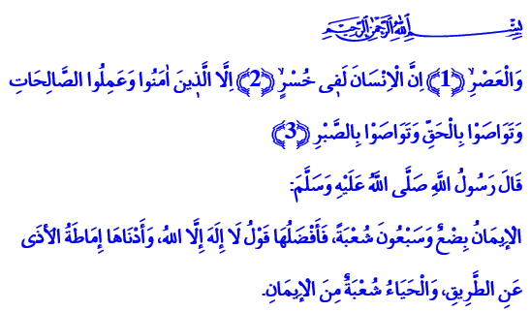
FACTS TAUGHT BY SURAH AL-ASR
Honorable Believers!
There is a surah in our Book, the Holy Quran, which is short but quite deep in meaning. It concisely puts forward the paths that will save mankind from eternal frustration and bring them to endless blessings. It is the Surah al-Asr. Surah al-Asr teaches us the five facts that give us life. Let us hear about them in today’s khutbah.
Honorable Brothers and Sisters!
The first fact that Surah al-Asr teaches us is the awareness of time. Man is a creature limited by time. Lord Almighty enjoins just at the beginning of the surah, اِنَّ الْاِنْسَانَ لَف۪ي خُسْرٍۙ . وَالْعَصْرِۙ “By time, indeed mankind is in loss.” He makes time the witness for mankind. Because it is one of the greatest blessings given to mankind. It is the most precious treasure entrusted to us so we may decorate our world with goodness and earn the afterlife. Wasting it and spending an irresponsible life is completely unbecoming for a believer. It is the greatest frustration for a person.
Brothers and Sisters!
The second fact taught to us by Surah al-Asr is the significance of the blessing of faith. As the Lord enjoins, اِلَّا الَّذ۪ينَ اٰمَنُوا He informed people that the first condition of being saved from loss and frustration is believing. Because a life spent without faith is the greatest of losses. Faith, on the other hand, is setting sail for good deeds and things, for the truth. A believer who sincerely recites the kalima shahada and kalima tawhid promises himself and his Lord that he will walk on the path of faith against evil, truth against falsehood, honor against contempt, and justice against cruelty. He agrees to stand with goodness and not evil.
Dear Brothers and Sisters!
The third fact that Surah al-Asr teaches us is the importance of good deeds. Our Lord enjoins, وَعَمِلُوا الصَّالِحَاتِ and says that our faith and good deeds will save us from eternal loss. Good deeds are the reflection of faith on acts. It is faith brought to life.
Every word and act that will earn us our Lord’s favor is a good deed. Putting all means to service for humanity is good deed just as our prayer, fast, alms, and hajj which we do with sincerity. Extending a hand to the oppressed to the victims, to the orphans is good deed. Becoming the eyes of the blind, the ears of the deaf, the hands and feet of the disabled is good deed. Protecting our peace, brotherhood, and values is good deed. The effort to prevent evil and make goodness prevail is good deed. As narrated in a hadith, removing an obstacle from the road is good deed. In short, good deed is suitable deed which means it suits Allah’s favor, human disposition, and society’s affairs.
Honorable Brothers and Sisters!
The fourth fact taught to us by Surah al-Asr which will save us from eternal loss is, وَتَوَاصَوْا بِالْحَقِّ which means siding with the truth at all times. It means guiding each other to truth. It means protecting ourselves and our brothers and sisters from falsehood, lies, tricks, sedition, and discord. It means never veering away from the truth and the path in our relationship with our Lord, with our neighborhood, with the universe under any circumstances.
Brothers and Sisters!
The fifth fact that Surah al-Asr teaches us is,
وَتَوَاصَوْا بِالصَّبْرِ which means being patient on the true path. It means recommending patience to one another. But it should be remembered that patience does not mean enduring falsehood. On the contrary, it means keeping on the path of truth.
Brothers and Sisters!
I would like to conclude the khutbah by the following verses of our Independence Poet, the ate Akif:
The Companions would make sure
To recite Surah al-Asr as they parted, why?
Because hidden in that surah is
The secret of salvation.
First comes the true faith, then peace.
Then truth, then fortitude.
There you go, humankind.
When those four comes together,
No more will you suffer.

Al-Asr, 103/1-3.
Muslim, İman, 58. Written by: General Directorate of Religious Services

