DATE: May 4, 2018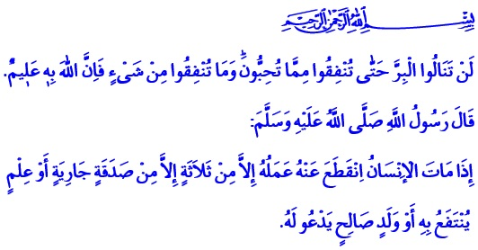 FOUNDATIONS – EVER-FLOWING
FOUNTAINS OF BENEVOLENCE
Honorable Believers!
Umar (r.a) had come into the possession of a date palm orchard in Khaybar. It was the first time in his life that he had such a beautiful orchard. He came into the presence of Allah’s Messenger (s.a.w.) and said, “O the Messenger of Allah! I would like to attain the countenance of Allah with this property, so what do you command me to do with it?” Our Prophet’s counsel on this land has been the keystone for the civilization of foundations for centuries to come. He (s.a.w.) said, “If you like, you may keep the corpus intact and give its produce as Sadaqah.” Thereupon, Umar endowed his orchard with the condition that it should not be sold, impropriated and bequeathed.
Dear Believers!
The divine messages of our sublime book the Holy Qur’an and the exemplary life of our Prophet (s.a.w.) have encouraged Muslims to do charity works throughout the history of Islam. Muslims have strived to perpetuate the charity, adopting as principle the verse from the Qur’an, “Never will you attain the good [reward] until you spend [in the way of Allah] from that which you love. And whatever you spend - indeed, Allah is Knowing of it.”. Both the companions of the Prophet and the following generations acted with the awareness that foundations are ever-flowing fountains of benevolence. Thus, the four corners of the Islamic world have been furnished with foundations – the most precious sources bringing goodness to humanity.
Dear Brothers and Sisters!
Foundation turns into permanent goodness with the wealth spent in hope of winning the love and countenance of Allah. Foundation is to build bridges of mercy and compassion with the fortune gifted to us by our Lord. Foundation is the attempt to transform the wealth entrusted to the believers into a way of worship. Foundation is the name of charity without abashing people, without letting the left hand know of what the right hand gives.

Brothers and Sisters!
Investments in generosity and bestowment casting aside selfishness and ambition turn into continuous merits by means of foundations. Our civilization hosts many foundations providing haven for passengers, food for the poor, jobs for the unemployed, support for those in debt, and family for students. Our foundations are means of home of affection for the orphans, a touch of healing for the sick, a helping hand for the needy, and peace for the elderly. Our historical foundations, established for the protection of the forests and the injured and homeless animals, are unique examples of regarding not only for humans, but also all beings –animate and inanimate alike– with compassion.
Honorable Believers!
Today, we still benefit from the foundations established by our noble-hearted forefathers at home and abroad. Mosques, fountains, hostelries, caravanserais, barracks, hospitals, libraries and many other charity services continue to exist as the reminders of our ancestors.
Come, let us protect these eminent heirlooms entrusted from the past; let us strengthen our tradition of foundations with a noble heart. Let us look after these sincere-at-heart foundations of ours, established for the ruling of the earth by benevolence and charity, goodness and beauty.
Dear Brothers and Sisters!
Bringing donations from our charitable nation to people in need from all over the world, the Turkiye Diyanet Foundation is building mosques in our country and in the crucial regions of the world. Our nation, enshrining the adhan in their hearts, is showing an intense interest in the charity campaign “One Brick from Me”, which has been initiated recently by the Presidency of Religious Affairs of Turkey and our Foundation, and is still continuing. For this reason, we would like to express our gratitude to our grateful community. May Allah Almighty accept your donations in His rule of excellence. Even the smallest donation you make will be a brick on the walls of a mosque maybe in Kosovo, or in Djibouti, or at a university campus mosque in any city of our country.
I would like to conclude this khutbah with the following hadith from Our Prophet, “When a man dies, his all acts come to an end except three: ongoing charity (sadaqah jariyyah), knowledge (by which people benefit), and a pious son or daughter who prays for him (after he is deceased).”

Muslim, Wasiyyah, 15.
Al-i ‘Imran, 3/92.
Muslim, Wasiyyah, 14. General Directorate of Religious Services

