LOCATION : NATIONWIDE
DATE : 02.06.2017
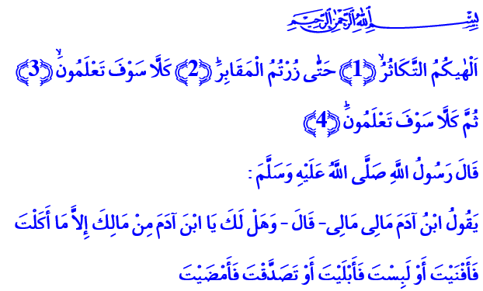
HUNGER OF FASTING CURES GREED
A Blessed Friday to You, Brothers and Sisters!
Infinite gratitude to Allah Almighty as He has granted us once again to reach Holy Ramadan, the season of grace and mercy. Salutations and peace to our Prophet and Allah’s Messenger who taught us that fasting is a school and a friend that mends our spirit.
Brothers and Sisters!
To the humankind who falls into the hands of desire and fancy and gets dragged into the swirl of ambition and cupidity, Allah the Exalted asks this crucial question: 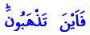 “Where are you going?” “Where are you going, oh, humans? Are you aware of your path?”
In this blessed Ramadan, the month of Quran, we must once again ask ourselves that question. We must shake and pull ourselves together with it. And we must ruminate over the answer.
Honorable Believers!
Ramadan is one of the best periods of time in which the answers we can give to this question are experienced in person. Because Ramadan reminds us of what we have forgotten. It calls us to contemplate. Ramadan calms down our spirit with Quran, prayer, remembrance, repentance, alms, and supplication. Fasting leaves us hungry from sunrise to iftar, thus curing greed which is another type of hunger and the source of all evil. Its origin is described in the Quran as “takathur” (boasting with abundance and competing for it). Allah Almighty enjoins us this fact in Surat at-Takathur:
“Competition in worldly increase diverts you until you visit the graveyards.” “No! You are going to know. Then no! You are going to know.” “No! If you only knew with knowledge of certainty.” 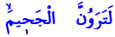 “You will surely see the Hellfire (if you do not stop your greed and competing in boasting with abundance).”
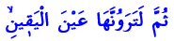 “Then you will surely see it with the eye of certainty.” 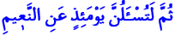 “Then you will surely be asked that Day about pleasure.”
Brothers and Sisters!
One day when our Prophet (pbuh) recited this surat, he followed up with this question upon which every single one of us must contemplate: “The son of Adam says: ‘My wealth, my wealth.’ And do you own anything except what you give in charity, such that you’ve spent it, or what you eat, such that you’ve finished it, or you wear, such that you’ve worn it out?”
Brothers and Sisters!
Avarice and greed are the source of all evil from which the humankind suffers. Isn’t the greed of global powers the reason for the bloodshed and suffering in our region? Isn’t it greed and nothing else that causes the balance of the universe to be disturbed, the nature to be ruined and the environment to be polluted, and the future of human species to be risked by modifying plants and seeds?
Brothers and Sisters!
As they come upon us to enlighten our hearts and cities every year in such an atmosphere, Ramadan and fasting offer us a great opportunity to get rid of greed, desire, and avarice. Ramadan and fasting remind us that our belongings do not actually belong to us, material and spiritual blessings are all but a test. They make us realize that the world is temporary, what’s permanent and everlasting is the afterlife. Ramadan teaches us to share and fasting teaches us to thank and be grateful. Ramadan inculcates us that real wealth is not the abundance of our fortune but the contentment of our hearts. It declares that the way to have bliss on the earth and salvation in the afterlife is not piling up wealth but winning hearts and accumulating prayers.
Then come, Dear Brothers and Sisters, Let us allow fasting and other worships we perform to let us deliver from greed and make us grateful and thankful believers. Let us surrender our hearts to Ramadan.
Dear Brothers and Sisters!
In these days as we experience the joy of Ramadan, we have been devastated as a nation upon hearing the news of martyrs fallen. Our children became martyrs for us to have a peaceful Ramadan and for the sake of our unity and togetherness, our peace and well-being, and our values. I wish Allah’s mercy upon our honorable martyrs, and a swift recovery to our veterans. May Allah grant patience and fortitude to our nation and to the families of our martyrs. Condolences to our nation.

At-Takwir, 81/26.
At-Takathur, 102/1-8.
Muslim, Zühd, 3. Written by: General Directorate of Religious Services

