LOCATION : NATIONWIDE
DATE : 24.11.2017
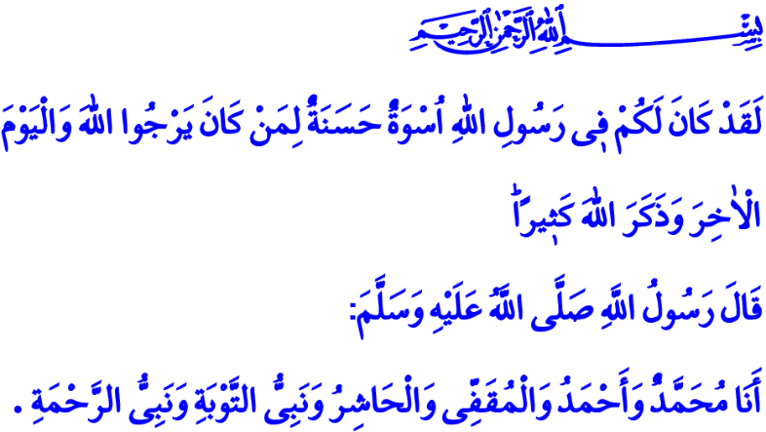
MAWLID AN-NABI
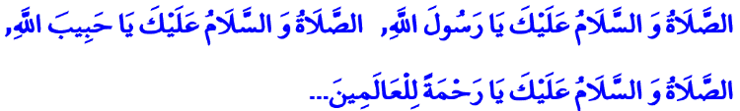
Peace and Blessings Be Upon You O Messenger of Allah! Peace and Blessings Be Upon You O Beloved of Allah! Peace and Blessings Be upon You O the Prophet Who is The Mercy to the Worlds!
Brothers and Sisters!
We are going to observe Mawlid An-Nabi together on the night that connects Wednesday to Thursday next week. We will once again joyfully celebrate the birth of our Master Muhammad Mustafa (pbuh), who was sent to this world as a mercy to the worlds. May your night be blessed in advance. May Our Almighty Lord never devoid us of the fondness and reverence we have towards The Greatest Messenger. May He never let us stray from his path and from his valuable sunnah for one moment.
Honorable Believers!
The Messenger of Allah is the last prophet who reminds the humanity of their responsibilities and duties. We are honored to be his ummah. He taught us to have an outlook on life and death, on the past and the future that is worthy of a believer. He showed us submission and loyalty, the right and the truth, mercy and conscience, justice and virtue, patience and tolerance with his exemplary life.
Brothers and Sisters!
Our first task as the ummah of our Prophet (pbuh) is to know and understand him correctly. To know and understand him correctly, one must first understand the reason and purpose of creation, humanitarian and moral values, his understanding of life and his merciful and compassionate view. Knowing our Prophet correctly will lead the way for us to understand our book of life, the Quran, better. Because our Holy Book was transformed into a living example by our Prophet.
Dear Brothers and Sisters!
Our Lord Almighty enjoins: “There has certainly been for you in the Messenger of Allah an excellent pattern for anyone whose hope is in Allah and the Last Day and [who] remembers Allah often.” Our Prophet (pbuh) stated that he is the prophet of mercy and repentance.
This verse and hadith shows us that the actual task for us is to understand our Prophet correctly and practice Quran into our lives correctly, just as he taught us by his life. It is to adopt the example and great moral character of our Prophet as a principle for ourselves. It is to endeavor to be an exemplary believer and a good person like him. It is to try our best to be a faithful spouse, a dutiful child, a compassionate grandfather and a merciful father like him. It is to be known as a trusted neighbor, a sincere brother or sister, a faithful relative like him.
Honorable Brothers and Sisters!
Today, mankind is in need of our Prophet’s (pbuh) great moral character and unique example more than ever. Because humanity is swaying in the whirlpool of disturbance and in the darkness of cruelty and injustice. Terror, violence, war and savagery are widespread especially in the Islamic geography because the ideals of our Prophet and his views on existence and humanity are not understood and embraced correctly. People are ruthlessly murdered in Islamic regions every day because the Prophet’s view that is based on not killing, but rejuvenating has been put aside.
Brothers and Sisters!
The greatest betrayal against the Prophet (pbuh) today would be the abuse of his holy name to support some dark ideas and the gathering of power and interests by abusing the noble values he presented to humanity. It also would be the shameless exploitation of the pure love and fondness that people have in their hearts for their prophet. It should not be forgotten that the sunnah and the character of our Prophet, his exemplary life and the noble values he passed down on us are trusted on each one of us as believers. May our Lord make us His trustworthy servants who protect what is entrusted to us.
Honorable Believers!
Today is the teachers’ day, to whom we entrust our children and who make great efforts to educate our generations. While I congratulate the day of our esteemed teachers, I also want to remind you that tomorrow is “International Day for the Elimination of Violence against Women”. With the opportunity these two days give us, we should never forget how our Prophet valued education, scholars and women. We should not neglect our tasks and responsibilities.
I want to conclude this khutba with these lines of our poet of independence for our Prophet:
What this world has, all is from him,
People are beholden to him, each and every one,
All humanity is beholden to that innocent man,
O Lord! Gather us on Judgment Day with this belief!

Al-Ahzab, 33/21.
Sahih Muslim, The Book of Virtues, 126. Written by: General Directorate of Religious Services

