LOCATION : NATIONWIDE
DATE : 08.12.2017
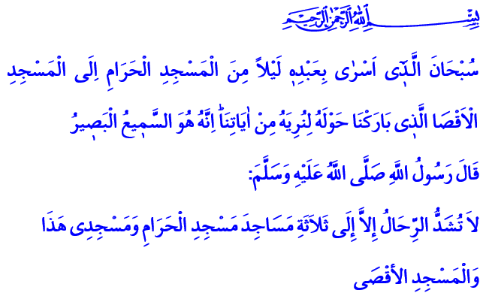
Our Bleeding Wound: Al-Quds
Blessed Friday to You, Honorable Believers!
Our Lord Almighty enjoins in the verse I have recited: “Limitless in His glory is He who transported His servant by night from the Inviolable House of Worship (at Mecca) to the Remote House of Worship (,at Al-Quds) - the environs of which We had blessed -so that We might show him some of Our symbols: for, verily, He alone is all-hearing, all-seeing.”
Our Prophet (pbuh) says in the hadith I have read: “Do not undertake a journey (for religious devotion) to visit any Mosque, but three: this Mosque of mine, the Mosque of al-Haram and the Mosque of Aqsa.”
Brothers and Sisters!
Al-Quds is the apple of our eyes. Al-Quds is our unceasing longing. Al-Quds is a city where many prophets strived for the cause of tawhid. It is a sacred and blessed city with its name and environs. Al-Quds is Al-Qudsi Ash-Sharif. It is also known as Bayt-al-Maqdis. Many prophets such as Ibrahim, Yaqub, Musa, Sulayman and Isa lived in Al-Quds and its surrounding region, which has been the cradle to many civilizations for thousands of years. The last sacred guest of Al-Quds became our Master Muhammad Mustafa (pbuh) with the event of Isra and Miraj. Moreover, the first kiblah of Islam, Al-Aqsa Mosque, is in Al-Quds.
Al-Quds and Al-Aqsa Mosque are the glad tidings of our Prophet that he entrusted to us. Al-Quds is an honorable city which every believer is attached dearly. Al-Quds is not just a mere piece of land. Al-Quds is not just the cause of those who live around Palestine and Al-Aqsa Mosque, it is a common cause of all Muslims and humanity.
Dear Brothers and Sisters!
Al-Quds found peace with the conquest of Umar. Muslims governed Al-Quds with a fair and just rule for many years. They respected everyone’s life, property and beliefs. In fact, even non-Muslims sought the justice of Islam for the disputes they had amongst themselves. But Al-Quds, Darussalam, the center of peace and tranquility, has been crestfallen for a long time and bleeding for years. Al-Quds is our bleeding wound and unceasing pain today. Al-Quds has suffered from all kinds of attacks and ceased to be the city of peace. Guns keep firing in the city of prophets. Innocent people are being murdered.
Brothers and Sisters!
Those living in and around Al-Quds are exposed to inhuman practices such as oppression, violence and isolation. People’s freedom of life, belief and thought are attempted against without mercy and their identity and character, dignity and honor are targeted. While it was not long ago that believers were kept away from Mosque of Aqsa, today they are trying to invade Al-Quds. A reckless understanding that totally disregards humanity, ancient traditions and international law is now in an effort to make Al-Quds the capital of Israel.
Let it be known that such reckless efforts would turn Al-Quds and its region into a land of conflict and disturbance. Such unacceptable attempts are a great blow dealt to the common sense and conscience of humanity. It is a dangerous step towards destroying peace, order and security.
Dear Believers!
Mankind suffers great pains due to negative developments like violence, oppression, war and migration. In addition to all these, such efforts against Al-Quds, far from foresight and discernment, devoid of mercy and conscience, have disturbed everyone with a common sense. Our task against all these is to never consent to these negative developments. It is to never tolerate what is wrong and unjust, wherever in the world and regardless of their victims.
It is a fact that there are many lessons to be taken from all the disasters, oppression and suffering that our brothers and sisters, the Islamic geography and the humanity are subjected to. Come, let us strengthen our brotherhood of faith with the consciousness of umma as quickly as possible. Let us protect each other's dignity and rights. Let each of us work with all our strength to free ourselves from the difficulties, pains and deprivations that we are in. Let us live our beliefs, our values and teach them to future generations.
Dear Brothers and Sisters!
Our holy nation has never severed and will not severe the ties of affection with Al-Quds, Al-Aqsa Mosque and our oppressed Palestinian brothers and sisters throughout history. With this in our minds, we open our hands to our Lord in this time of Friday and ask: O Allah! Let us be among those Muslims who feel the pain of all their oppressed brothers and sisters in the world and use everything they have to help them, materially and spiritually! Let us not side with those who lack foresight, discernment, conscience and those who oppress!
O Allah! Do not allow those who try to invade Al-Quds and Islamic cities, those who bring disorder and sabotage peace under the guise of improvement! Accept our prayers for the sake of this holy Friday, o Allah!

Al-Isra, 17/1.
Sahih Muslim, The Book of Pilgrimage, 511. Written by: General Directorate of Religious Services

