Date: 16/03/2018
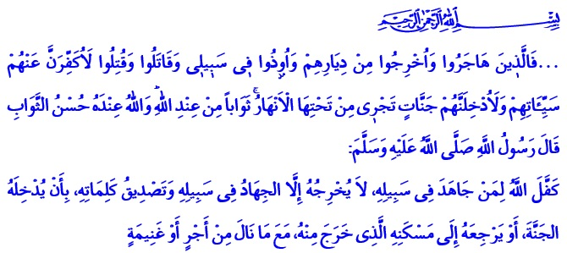

OUR NATION’S STRUGGLE FOR EXISTENCE:
THE VICTORY OF ÇANAKKALE

Honorable Believers,
In the verse I have recited, our Almighty Lord enjoins:
“Those who emigrated or were evicted from their homes or were harmed in My cause or fought or were killed - I will surely remove from them their misdeeds, and I will surely admit them to gardens beneath which rivers flow as reward from Allah, and Allah has with Him the best reward.”

In the hadith I read, our Prophet (s.a.w.) says:
“Allah guarantees to the person who carries out Jihad for His Cause and to confirm the Kalimah al-Tawhid, that He will either admit him into Paradise or return him with his reward or the booty he has earned to his residence from where he went out.”

Dear Believers,
Homeland is where people build their homes and find peace. It is the place where people live in safety and freedom far from oppression and tyranny. Homeland love is a unique feeling that Allah the Almighty engraved in our hearts. While defending this homeland with a noble struggle, our heroic ancestors took the power from their faith, and survived thanks to their love for the homeland. They did not hesitate to sacrifice their lives with the aim of preventing the adhan from being quieted, our flag from falling, and our honor from being broken. Because defending the homeland is to defend all the material and spiritual values that a nation possesses. The reward for defending our sacred values is either being a veteran or a martyr.

Honorable Believers,
Martyrdom is such an eminent rank that it has been praised by our Lord and desired by our Prophet (s.a.w.). Martyrdom is to lay down one’s existence for the domination of the right, the truth, and justice. It is to witness goodness and peace against evil and tyranny. The reward of this testimony is honor in this life, and paradise in the Hereafter. Martyrs are alive, they do not die, they are not called “dead”. In this respect, our Almighty Lord says:
“And do not say about those who are killed in the way of Allah, ‘They are dead.’ Rather, they are alive, but you perceive [it] not.”

Honourable Believers,
There are many glorious victories that change the course of history. The victory of Çanakkale is one of them. Çanakkale is the place where people whose hearts beat by an unshakable belief and the love of the homeland, make their bodies shields against e heartless invasion. Çanakkale is the place where Mehmetçik fell to the ground for the sake of independence and future with the motto “A martyr if I die, a veteran if I survive.” Çanakkale is the place where a nation that overflowed the oceans and made the history of re-existing. Çanakkale is the name of the struggle of a nation that came together from all corners of Anatolia, from Rumelia, Baghdad, Damascus, Skopje, Bosnia. Their languages and colors were different, but they became one for the same cause. Çanakkale is a flag carried by our ancestors, women and men, and a land hosting that saintly spirit in every inch.
Çanakkale is the place where Mehmetçik adopted as a principle the verse “... And do not let the hatred of a people prevent you from being just...”, made the wounded enemy soldiers drink water and carried them on their back, acted humanly to the captives, and taught the morality of war to the world.
Çanakkale is the place where the good tidings “So do not weaken and do not grieve, and you will be superior if you are [true] believers.” manifested itself.

Honorable Believers,
Those aiming at our unity, solidarity and brotherhood, today, as it was yesterday, are surrounding us with no conscience or moral value. Terrorist organizations and gangs of persecution are trying to disrupt the peace and unity of our beloved nation. However, the end of those who try to create trouble among us, weaken our will and prudence will be disappointment. With the strength we receive from our faith and the inspiration we take from our history, we are struggling to establish peace, brotherhood and justice today as well.

Then, my brothers and sisters,
Let us not forget our history, our culture, our values, and our victories that made us and brought us to today. Let us teach our children the spirit that made Çanakkale insurmountable, the glory of our land which is full of the heroic memories of our martyrs. Let us keep the trust of our ancestors safe. Let us move this trust to the future with the same conscience and ideal.

Honorable Muslims!
Next Monday, we will once again have the pleasure of reaching the three months, which is the season of mercy, fertility and forgiveness. On the night that connects Thursday to Friday, we will also be celebrating the Night of Raghaib. May our Almighty Lord let all of us benefit from the three months in the most beautiful way, and reach Ramadan by gaining His countenance. May Allah grant mercy to the martyrs who sacrificed themselves for our religion, our holy things, our homeland, our nation, peace and blessings; and bestow healing to our veterans.

Brothers and Sisters,
Today, in all mosques across the country and the Presidency of Religious Affairs of Turkey and the Turkey Diyanet Foundation will receive donation to help our ongoing construction of mosques at home and abroad. We are waiting for your donation. And those who say “I would like to have a hand in” could type CAMİ and send an sms to 1379, and donate 10 TL by this way. May Allah accept your donation.
I end up with a hadith of our Beloved Prophet (s.a.w.):
“O Allah! Make Rajab and Shaban a blessing for us, and help us reach the month of Ramadan!”

Al-i ‘Imran, 3/195.
Bukhari, Tawhid, 28.
Baqarah, 2/154.
Ma’idah, 5/8.
Al-i ‘Imran, 3/139.
Tabarani, al-Mu’jam al-Awsat, IV, 189. Issued by: General Directorate of Religious Services

