LOCATION : GENERAL
DATE : 21.07.2017
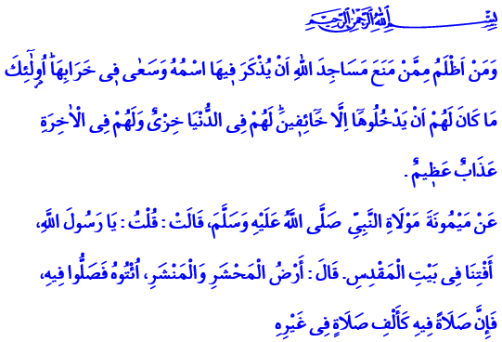
OUR UNENDING SORROW:
JERUSALE AND MASJID AL-AQSA
Honorable Believers!
Our Prophet’s (pbuh) wife Maymunah asked him: “O Messenger of Allah! Would you tell us about Baitul Maqdis?” Allah’s Messenger says: “It is the land of the Resurrection and the Gathering. Go and pray there, for one prayer there is like one thousand prayers elsewhere.” When Maymunah asks, “What if I cannot travel and go there, o Messenger of Allah?” the Messenger of Mercy answers: “Then send a gift of oil to light its lamps, for whoever does that is like one who goes there.”
Venerable Muslims!
Imagine a city that was the home to many prophets’ fight for oneness. Imagine a city that was the qibla of three monotheistic religions. Imagine a city that was deemed sacred and blessed with its name and site. That city is Jerusalem, the holy city, also known as Baitul Maqdis. The cradle of civilizations for thousands of years and an attraction center, Jerusalem and its surrounding region witnessed many prophets like Abraham, Ishmael, Jacob, Joseph, Moses, Solomon, and Jesus. Masjid al-Aqsa, the first qibla of Islam and the place where our Prophet (pbuh) experience Isra and Mi’raj are also in Jerusalem. Allah’s Messenger wanted us to have a spiritual bond with Baitul Maqdis for that reason. He advised us to perform umrah in that city.
Brothers and Sisters!
Jerusalem achieved peace with the conquest of Caliph Umar. Especially during the Ottoman period, Muslims ruled justly and mercifully, never intervening in the life, property and religious freedom of people from different religions. In fact, non-Muslims sought the justice of Islam in resolving disputes among themselves. The best example of our religion’s vast tolerance and embracing understanding is the inscription on the inner wall of Bab el-Khalil. Our ancestors wrote, “La ilahe ilallah, Ibrahim Halilullah,” which means “There is no god but Allah, Ibrahim is His friend.” Thus, they engraved on the walls of Jerusalem the name of Abraham who is considered a prophet by members of all monotheistic religions.

Honorable Believers!
It should be stated regretfully that Jerusalem, which has been the Darussalam or the center of peace and calm in history, has been in grief for a long time. Masjid al-Aqsa, our first qibla, is wounded. Jerusalem is now far away from being the city of peace after experiencing all kinds of transgressions. The ancient city that has in its every corner the collective traces and memories of humankind now longs for peace. The unity, togetherness, and most sacred values of believers are targeted more and more every day in the land of prophets. Innocent people are murdered in cold blood. Muslims are cruelly and barbarically prevented from worshipping in their own mosques. Friday prayer could not be performed at Masjid al-Aqsa last week for the first time since 1967. It should be remembered that there can be no legal grounds, no religious basis, and no humane reason for shutting down a temple. On those who keep people off their temples and destroy those temples, Allah enjoins the following quite clearly: “Who are more unjust than those who prevent the name of Allah from being mentioned in His mosques and strive toward their destruction? It is not for them to enter them except in fear. For them in this world is disgrace, and they will have in the Hereafter a great punishment.”
Honorable Believers!
As our region suffers great pain, the incidents in and around Masjid al-Aqsa have caused tremendous concern for every person with common sense. We believe that the occupation will end at once in this holy land that houses prophets, and reason, moderation, and peace will prevail. It is our greatest wish that common sense comes into action in Jerusalem, the heart of Muslims and the common value of all humankind.
It is a fact that as Muslims there are no embarrassing inhumane practices in our history such as right violations, cruelty, and savagery. However, all the disasters, cruelty, and oppression suffered by our brothers and sisters today teach us a lesson. We must strengthen our brotherhood of faith with the mentality of an Ummah as soon as possible. We must protect the dignity, rights, and gains of one another. Each one of us must work with all our power to make the Ummah of Islam a glorious one again.
Dear Brothers and Sisters!
We as a nation have never broken our spiritual ties with Jerusalem and Masjid al-Aqsa throughout history. We cannot. With that mentality, we open our hands in Friday prayer and supplicate to Allah: O Allah! Make us feel in our hearts the pain of all oppressed brothers and sisters in Jerusalem and around the world! Do not let us side with the short-sighted, the unwise, the heartless, and the cruel! O Allah! Do not allow those who attempt to occupy Masjid al-Aqsa and the cities of Islam! Help our Muslim brothers and sisters so they may overcome the hardships they are going through as soon as possible! Grant us to keep justice alive once again as a glorious Ummah! Answer our prayers on this blessed Friday, o Allah!

Ibn Majah, İkâmetü’s-Salât, 196; Abu Dawud, Salât, 14.
Al-Isra, 17/1.
Abu Dawud, Salât, 14; Ibn Majah, Menâsik, 49.
Al-Baqarah, 2/114. Written by: General Directorate of Religious Services

