LOCATION : NATIONWIDE
DATE : 03.11.2017

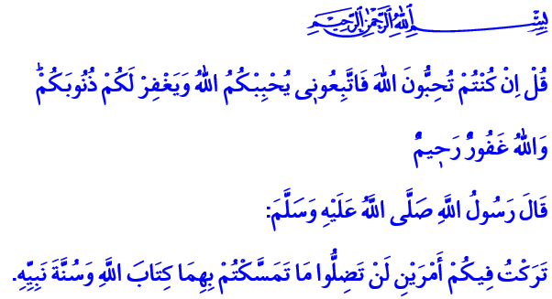
SUNNAH: THE PROPHETIC GUIDANCE
Honorable Believers!
Our Lord Almighty enjoins in the verse I have recited: “Say (O Prophet): ‘If you love Allah, follow me, (and) Allah will love you and forgive you your sins; for Allah is much-forgiving, a dispenser of grace.’ ”
Our Prophet (pbuh) says in the hadith I have recited: “I have left behind over you that which if you hold fast to it, you will never go astray: the book of Allah and the sunnah of His prophet.”
Dear Brothers and Sisters!
One of the fundamentals of belief is the belief in the prophets. As believers, we accept all commissioned prophets from Adam to our Prophet Muhammad Mustafa (pbuh). We believe in our Prophet and all that he proclaimed. We sincerely express this belief in the kalima shahada (confession of faith) and kalima tawhid (confession of Allah’s oneness), which are oral testimonies of our faith. We know and believe that without the belief in our Prophet, there could be no belief in tawhid (oneness). One cannot be a true believer without loving the Prophet more than everyone and everything. We know and believe that one cannot live Islam truly without following his authentic sunnah.
Honorable Brothers and Sisters!
We learn our holy religion Islam from two main sources. The first one is our guide to salvation: the Quran. The second one is the noble sunnah of our Prophet which enlightens the ages. Just like there is no faith in Allah without faith in prophets; it is not possible to truly understand Quran and practice it in our lives without the exemplary life, character, authentic sunnah and hadiths of our Prophet. Because Quran was revealed to our Prophet; it was understood with him and reflected to the real life through his example.
Brothers and Sisters!
Our Lord Almighty says in the Quran, 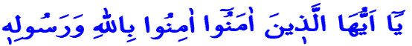“O you who believe! Believe in Allah, and His Messenger…” and enjoins us to believe in Him and His Messenger together. He also says, 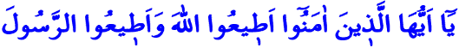 “O you who believe! Obey Allah and obey the Messenger…” and enjoins us to submit to Him while following His Messenger. As stated in our Holy Book Quran, following our Prophet is directly related and connected with the love for Allah. Thus, a faith without respect for the Prophet would make one neither a believer, nor a Muslim.
Honorable Believers!
Our Prophet is a source of mercy and guidance sent to all mankind. He told us about the reason of our existence. He taught us to properly worship Allah in the right way and the way to earn His countenance. He invited us to virtue and goodness with his words and his character.
It is a fact that, if a believer seeks happiness in this world and hereafter, then he must follow the authentic sunnah of our Prophet (pbuh). Truly following the sunnah begins with understanding Quran correctly as our Prophet proclaimed it and practicing it in our lives. Following the sunnah leads to a profound heart, an open mind, an exalted soul and a virtuous character. Following the sunnah is to stand firm against ignorance and indolence, spite and hatred, violence and discord. It is to pursue supreme ideals always in order to leave a more livable world to the future generations. To follow the sunnah is to dress ourselves in sagacity and perception, loyalty and reliability, patience and strength, mercy and compassion, respect and love, and more importantly, in morality.
Honorable Brothers and Sisters!
Telling the exemplary life of our Prophet to us, the sunnah and hadiths are the common heritage of all believers. Every believer who loves our Prophet, who embraces His example and walks in His path, belongs in the fellowship of the sunnah. No individual or group has the right to regard themselves as the sole protectors of the sunnah. Likewise, the understandings and attempts on discrediting and excluding the sunnah are just futile efforts. It should not be forgotten that marginalizing and separatist discourses based on the holy sunnah of Allah’s Messenger (pbuh) would harm our brotherhood, our fondness, our unity and solidarity.
How happy is the one who walks on the path of Allah and His Messenger Muhammad Mustafa (pbuh)! How happy is the one who follows Allah’s Book and the sunnah of His Messenger!
Salutations and peace be upon you O Messenger of Allah! Salutations and peace be upon you O the Beloved of Allah!
Brothers and Sisters!
I ask compassion from our Lord Almighty for the honorable martyrs who sacrificed their lives yesterday for the continuity and peace of our nation; and I offer my condolences to our nation and their next of kin; and wish them patience. May our Lord Almighty never separate us from the values that our martyrs gave their lives for.

Ali ‘Imran, 3/31.
Muwatta, Fate, 3.
An-Nisa, 4/136.
An-Nisa, 4/59. Written by: General Directorate of Religious Services

