LOCATION : NATIONWIDE
DATE : 17.11.2017

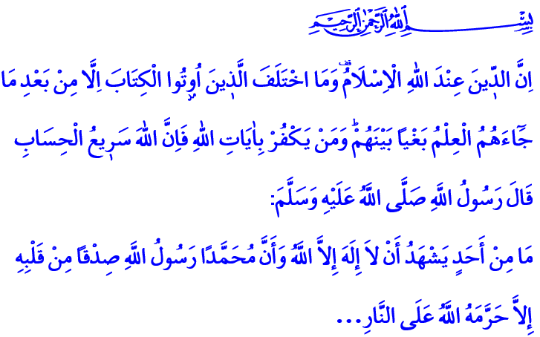
THE RELIGION BEFORE ALLAH IS ISLAM
Blessed Friday to You All, Brothers and Sisters!
A Jewish young man working in the service of the Messenger of Allah (pbuh) contracted a grave illness. Our Prophet, the example of fidelity, visited this young man in his deathbed. The Messenger of Mercy could not find it in his heart to let this young man leave the world like this and he invited him once again to become a Muslim, with a tone full of mercy. The young man hesitantly looked at his father. It was obvious that he was afraid of his family’s reaction if he became a Muslim. But the result was not as he feared and his father asked him to accept this kind invitation of Allah’s Messenger. Then the young man recited the Testimony of Faith and was honored with Islam. Extremely happy about this situation, our Prophet stated his gratefulness like this: “Praises be to Allah, Who saved the boy from the fire through me.”
Honorable Believers!
Our Lord Almighty enjoins in the verse I have recited at the beginning of this khutba: 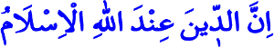
“Truly, The religion before Allah is Islam.”
Our Prophet (pbuh) says in the holy hadith I have recited: “There is none who testifies sincerely that none has the right to be worshipped but Allah and Muhammad is his Apostle, except that Allah, will save him from the Hell-fire.”
Brothers and Sisters!
Starting with Prophet Adam, all prophets invited the humanity to only submit to and worship Allah the One and Only. In times when people strayed away from the faith of Tawhid and nearly forgot the reason and wisdom of their creation, our Lord Almighty repeated His invitation through the prophets. The last Messenger of this holy cause was our Prophet Muhammad Mustafa, sent as a mercy to the worlds. Just like the prophets before him, he invited people to only believe in and worship Allah, to the right and the truth, to knowledge and wisdom, to morality and virtue.
“This day have I perfected your religion for you, completed my favor upon you, and have chosen for you Islam as your religion.” Just as it is stated in this verse, Islam was perfected with the Greatest Messenger. He taught humanity the ways of reaching happiness in this world and hereafter.
Honorable Brothers and Sisters!
We believe that all prophets are the servants and messengers of Allah and also believe in the original books that were sent through them. Again, we know and believe that the only religion valid before Allah until the Day of Judgement is Islam. The eternal salvation of all mankind is only possible by submitting to Allah’s last religion, namely Islam. The happiness in this world and hereafter depends upon the belief in the rejuvenating messages of the Quran and the unique example of our Prophet.
Each believer who recites the Testimony of Faith with all his heart, who comes into the presence of Allah with obedience, good deeds, charity and goodness will be honored with our Lord’s mercy. Whoever does not accept Allah the Almighty as his Lord, Islam as his religion, Muhammad Mustafa (pbuh) as his Prophet and Quran as his book is wronged themselves. Our Almighty Lord, in the Qur'an, enjoins:

“And whoever seeks a religion other than Islam, it will never be accepted of him, and in the Hereafter he will be one of the losers”
Honorable Believers!
Those who can not tolerate the spread of Islam throughout the world and settle into the hearts of people have always engaged in various attempts against our religion. Islam is the hope of salvation for all mankind and a religion of mercy and compassion, peace and trust. But certain people try to defame Islam through unjust accusations like terror and violence. In many parts of the world, Muslims are exposed to practices that are incompatible with conscience and justice such as marginalization, discrimination, oppression, violence and persecution. Islamophobia spreads rapidly each passing day.
Brothers and Sisters!
Throughout history, the attempts on harming and destroying our religion, our values and our beliefs have done no harm, and with Allah’s will, are going to do no harm to the truth of Islam. As long as we know the value of our religion despite all these unfortunate events; offer our thanks to our Lord Who granted us this religion and learn our holy religion through authentic knowledge based on Quran and sunnah and teach it to future generations. As long as we properly practice the Islamic principles of faith, prayer and morality and be a good example for humanity. Let us protect our faith and prayers, brotherhood and fondness, in short, all our values together.
Dear Brothers and Sisters!
I want to conclude with these prayers Quran taught us:
“Our Lord! Let not our hearts deviate (from the truth) after You have guided us, and grant us mercy from You. Truly, You are the Bestower”
“Our Lord! Forgive us our sins and our transgressions, establish our feet firmly, and give us victory over the disbelieving folk.”

Buhârî, Cenâiz, 79.
Âl-i İmrân, 3/19.
Buhârî, İlim, 49.
Al-Ma’idah, 5/3.
Sahih Muslim, The Book on Government, 31.
Ali ‘Imran, 3/85.
Ali ‘Imran, 3/8.
Ali ‘Imran, 3/147. Written by: General Directorate Of Religious Services

