LOCATION : NATIONWIDE
DATE : 11.08.2017
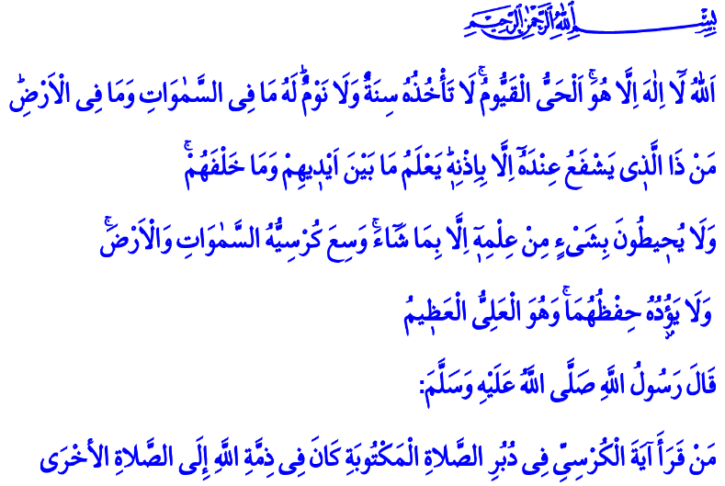
THE TRUTHS WE LEARN
FROM AYAT-AL KURSI
A Blessed Friday to You, Brothers and Sisters!
There is a magnificent verse in the Holy Quran that is called Ayat al-Kursi (The Throne Verse). In this verse, our Lord introduces Himself to us in a concise manner. He gives examples from His beautiful names. Our Prophet (pbuh) recommends us to recite this verse by saying: “Those who recite Ayat al-Kursi after a prayer will stay under Allah’s protection until the next one.” Let us listen the truths that our Lord teaches us in Ayat al-Kursi in today’s khutba.
Honorable Believers!
The first truth that our Lord teaches us in Ayat al-Kursi is that there is no god but Allah. We are all servants of Allah. We are helpless against His might. We are all in need of his help, mercy and forgiveness. He is our only sanctuary, only support that we could open our hands and ask for mercy against many troubles of this world. Our task is to be a rightful servant to our Lord. It is to stay on the straight path, As-Sirat Al-Mustaqim, that the Quran and our Prophet (pbuh) guide us towards.
Brothers and Sisters!
Our Lord is 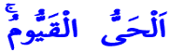. He is ever-living, eternal. He is the One who gives and takes life. He is the sustainer of all existence. Our task is to live our lives conscious that the world is mortal and this life is merely entrusted to us.
Allah is beyond the attributes of His creation. He knows and commands our every moment and every action. Our task is to never forget that our Lord is nearer to us than our jugular vein.
To Him belongs whatever is in the universe. The Dominion, The Sovereignty and The Blessing are His. Wealth and poverty, abundance and scarcity all came from Him. Our task is to have a tongue that recites, a heart that thanks and a mind that contemplates under any circumstances.
Written by: General Directorate of Religious Services
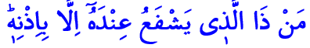Nobody could help us or harm us except with His permission. What would give us value in the sight of Allah is our good deeds and our faith, submission and loyalty towards Him. Our task is to stay true to our pact of faith with our Lord. It is to submit to His approval only our good deeds, our penitence and prayers.
Honorable Believers!
Another truth Ayat al-Kursi teaches us is 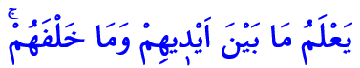, meaning nothing will be hidden from our Lord or be a secret to Him. He knows every word that comes of our mouth, each feeling in our hearts and every thought in our minds. Our task is to refrain from evil with all of our being. It is to make our hands, tongue, mind and heart a center and servant of goodness.
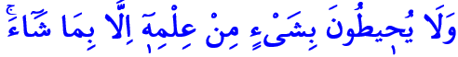 Our Lord is the only source of knowledge and truth. We know only what He teaches us. We hear only what He allows us to hear. We speak only what He allows us to speak. We see only what He allows us to see. Our task is always to be on the side of what is right. It is to be the speaker of the truth. It is to remove obstacles on the way of the truth within our power. It is to be aware of those who deceives people by disguising as a good person.
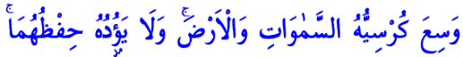 Our Lord’s might, supremacy, greatness and knowledge encompasses all. He is the One who rules over everything without any weariness. Our task is to be a servant and pray only and only for the Lord of the Worlds. It is not to worship any other. Because 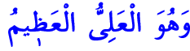 Allah is the Most High, the Most Great. We recite this truth in each rakat of our prayers. We say in our rukus (bowings) 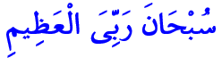and in our sujuds (prostrations) 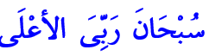, meaning we praise our Lord by saying “How Perfect is my Lord! You are beyond any flaw.”
Honorable Brothers and Sisters!
Come! Let us contemplate the profound meaning within Ayat al-Kursi. Let this verse that we recite every day be a verbal expression of our pact of faith with our Lord. Shielding us against evil, let this verse that we recite after prayers protect us from the malice, calamity and troubles of the wicked. May our Lord never allow us to leave the truths of Ayat al-Kursi, the principles of our Holy Book.

Taberânî, el-Mu’cemü’l-Kebîr, III, 83.
Al-Bakara, 2/255.

