LOCATION : NATIONWIDE
DATE : 23.06.2017
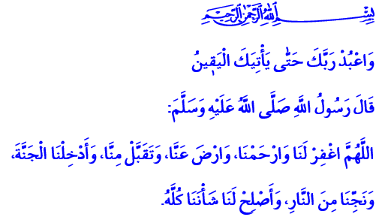
MAKING OUR WHOLE LIFE RAMADAN
Fellow believers who have packed this beautiful mosque with faith in your hearts! A blessed Friday to you all.
Honorable Believers!
We are both happy and sad today. We are happy. Because we have experienced to our hearts’ content the civilization of Ramadan. We have approached Eid as pupils of Ramadan school. We are sad. Because we bid farewell to the Holy Ramadan which every year brings us the Quran again as well as the piety of fasting, the joy of iftar, the abundance of sahur, and reminds us what we have forgotten. Here goes the month of mercy that surrounds our cities, tables, and souls with its richness and generosity for a month. May Allah Almighty make us among His servants that have done the best in Ramadan. May He let us reach the Eid and many more Ramadans with faith, knowledge, and wisdom.
Dear Believers!
We fasted in this unique period of time that, with its mercy and grace, brought our souls closer to Allah and elated our spirits with virtue and abundance. We were tested with hunger and thirst in long summer days. We said “I am fasting” against any desire and appetite. Our patience was tested. We guarded our mind, hands, tongue, and all in all ourselves against evil. We surrounded ourselves with compassion and mercy as we fasted. We once again sympathized with the poor and needy. We better understood the value of making do with less. We read our guide for the true path, the Quran, which heals souls and brings peace to believers in both worlds. We tried to understand and practice it.
Dear Congregation!
We performed prayer day and night in Ramadan by virtue of the verse “He has certainly succeeded who purifies himself and mentions the name of his Lord and prays.” We came closer to Allah with prayer in confession of our helplessness. We performed tarawih prayers, gathering around the same goal and standing side by side. We made an effort to get off the burden of sin with gratitude and prayer during iftar, with repentance and asking for forgiveness during sahur.
In awareness of the verse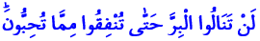 “Never will you attain the good until you spend in the way of Allah from that which you love,” we extended a helping hand to the poor and needy with zakat, alms, fitr, and iftar tables. We opened our souls to our neighbors, orphans, and homeless. We had the joy of sharing, solidarity, and giving without taking back for the sake of Allah.
Ramadan has been a fruitful school for us for a month. It gave us spiritual education. It taught us discipline in life. It reinforced feelings of fraternity, unity, and togetherness. It allowed us to contemplate on the years we lived and to revise our future.
Honorable Believers!
As Ramadan bids us farewell soon, the month of mercy asks us to always keep all the beautiful things it has taught us. Then come! Let us fulfill our duties and responsibilities until the final moment of the test by virtue of the verse in which Allah enjoins, “Worship your Lord until there comes to you the certainty.” Let us make an effort every moment to earn Allah’s favor by virtue of the hadith of our Prophet (pbuh) in which he says, “The most beloved deed to Allah is the regular consistent one.” Let us be always sincere to Allah, to ourselves, and to one another. Let us practice and make others practice the things we taught in Ramadan. Let us make our whole life Ramadan in return for the generosity Ramadan offers to us.
Honorable Brothers and Sisters!
Before I finish my khutbah, I would like to remind you something. The traffic accidents that happen every year turn the peace and joy of Eid into grief and pain. A lot of brothers and sisters are killed in these accidents. A lot of families perish. A lot of parents, children, and relatives are left teary-eyed and destitute. Hopes and futures die away. At this point, I urge all brothers and sisters to adhere to the traffic rules, be patient and careful, and look after the rights of one another. May Allah let all brothers and sisters who will make an Eid trip come back home safe and sound. May He protect us from any accident, trouble, and tribulation.
I would like to finish my khutbah with the following prayer from our Prophet (pbuh): “O Allah! Forgive us! Have mercy on us! Accept our worship, good deeds, and prayers! Admit us to your Paradise, save us from Hell! Rectify all our affairs.”

Al-A’la, 87/14-15.
Ali ‘İmran, 3/92.
Al-Hijr, 15/99.
Bukhari, Rikâk, 18.
Ibn Majah, Dua, 2. Written by: General Directorate of Religious Services

