LOCATION : NATIONWIDE
DATE : 10.03.2017
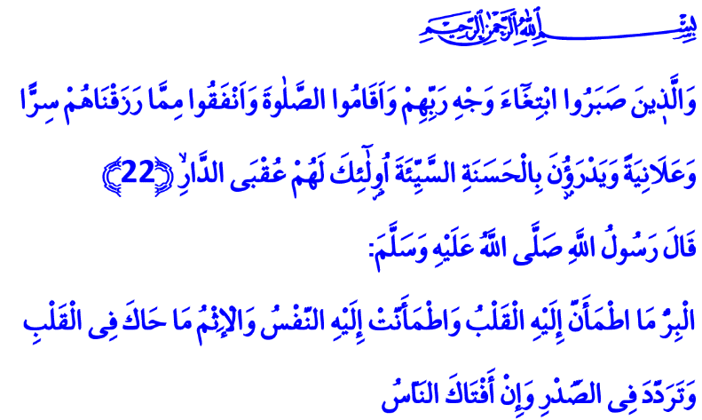
ONLY THROUGH GOODNESS WE CAN PREVENT EVIL
Honorable Believers!
Vabisa, a companion of our Prophet (pbuh), was a new Muslim. Vabisa, unable to grasp the merciful and graceful messages of Islam, wanted to ask some questions to our Prophet (pbuh). One of these questions was about what is good and what is evil. He went to the Messenger of Allah to ask him questions. He reached Prophet Muhammad (pbuh), about whom he said “no other company would give me greater joy”. The Messenger of Mercy noticed him approaching and said “Come closer Vabisa!” After listening to his question, he gave this answer: “Vabisa! Consult your heart and your conscience about good and evil! Because goodness is what gives your heart peace and your conscience comfort. Evil is what gives your heart unrest and your conscience worry and doubt, even if other people approve of it.”
Honorable Brothers and Sisters!
Goodness is existence, evil is emptiness. Goodness is peace. Evil is darkness. Goodness is to seek our Lord’s countenance. Evil is to walk step by step towards His anger. Goodness is the behavior befitting to the traits of having a sound mind, a sound heart and a sound nature, that is the trait of being the most honorable of all creation. Evil is the behavior that lowers a person, the atrocity that reduces his worth both in the sight of Allah and other people. Goodness is a noble trait our Great Lord has put within the fitrah (natural disposition) of man. Evil is a black spot that stains the heart. Goodness is the loyalty towards Allah Almighty, owner of the purest nature of man. Evil is to lose this loyalty. Goodness is the greatest power that will wipe evil and malice off the earth. Evil is destined to become vanquished and defeated against goodness.
Brothers and Sisters!
Our Holy Book first tells us about what goodness is not, before telling us what it is.
لَيْسَ الْبِرَّ اَنْ تُوَلُّوا وُجُوهَكُمْ قِبَلَ الْمَشْرِقِ وَالْمَغْرِبِ meaning “Goodness is not that you turn your faces toward the east or the west.” It does not consider it goodness to reduce prayers to mere formalism and be pious just to be seen by people.
The Holy Qur’an defines the real goodness as follows: True goodness is, مَنْ اٰمَنَ بِاللّٰهِ وَالْيَوْمِ الْاٰخِرِ وَالْمَلٰٓئِكَةِ وَالْكِتَابِ وَالنَّبِيّ۪نَۚ in other words it is to believe in Our Lord, who delivers us from all evil. It is to believe in the Last Day, the angels, the Book and the prophets.
وَاٰتَى الْمَالَ عَلٰى حُبِّه۪ ذَوِي الْقُرْبٰى وَالْيَتَامٰى وَالْمَسَاك۪ينَ وَابْنَ السَّب۪يلِ وَالسَّٓائِل۪ينَ وَفِي الرِّقَابِۚ
True goodness is to give wealth, in spite of love for it, to the needy, orphans and the poor. It is to free man from all kinds of slavery. True goodness is, وَاَقَامَ الصَّلٰوةَ وَاٰتَى الزَّكٰوةَۚ to establish prayer. It is to give zakat willingly. True goodness is, وَالْمُوفُونَ بِعَهْدِهِمْ to fulfill ones promise when one promise, to be attentive to one’s trust. True goodness is, وَالَّذ۪ينَ صَبَرُوا ابْتِغَٓاءَ وَجْهِ رَبِّهِمْ to be patient during ease and hardship, only to seek the countenance of Allah.
True goodness is, وَيَدْرَؤُ۫نَ بِالْحَسَنَةِ السَّيِّئَةَ to be able to avert evil through good, destroy it through good. Because a believer is the one who devotes his life to the good and gives his life meaning through good. A Muslim is the one who stands against all kinds of evil with his hand, mouth, heart and body and soul.
Honorable Brothers and Sisters!
I regret to tell you that goodness today remains in the background compared with evil. Evil keeps surrounding our world day by day. At an alarming rate, mankind loses his conscience, justice, rightness and compassion for the sake of following his desire, passion and lust. He becomes an entity who does not help anyone but himself. He forgets that true help, true goodness is the one that you give to others.
Brothers and Sisters!
As believers with a cause to spread goodness and prevent evil, we have a very important responsibility. Regardless of the circumstances, we have to keep the belief that there are still good people in this world alive. We must never let evil defeat goodness. We must not forget that serving the goodness and preventing the evil lead to happiness in this life and hereafter.
Brothers and Sisters!
As pilgrims on the path of goodness we pray to our Lord in this sacred hour with open hands: O Lord! Grant us the ability and power to remove all evil surrounding our region and all mankind! Grant us help to build a world together where goodness prevails! Enable us to leave a better, more livable earth to future generations!

İbn Hanbal, IV, 227; Dârimî, Büyu’, 2.
Al-Baqarah, 2/177.
See Hud, 11/114; Ar-Ra’d, 13/22. Written by: General Directorate of Religious Services

