LOCATION : NATIONWIDE
DATE : 07.04.2017

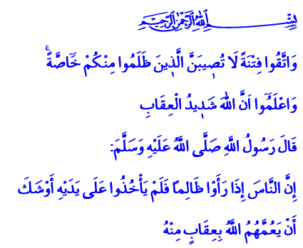

PERSECUTION DOESN’T LAST FOREVER
A Blessed Friday to You, Dear Brothers and Sisters!
In the verse I have recited, the Almighty Lord enjoins: “And fear a trial which will not strike those who have wronged among you exclusively, and know that Allah is severe in penalty.”
Our Beloved Prophet (pbuh) makes the following warning to all of us in the hadith I have read: “If people see an oppressor and do not stop his oppression, Allah will surely bring a wrath overall to them.”
Brothers and Sisters!
The region of Islam has been surrounded by dark clouds for a long time. While tens of thousands of children die as a result of the famine and drought going on in Africa on one side, unfortunately tens of thousands more approach death. On the other side, hundreds of thousands of people have lost their lives in the war that has been going on nearby us. Women, children, and innocents continue to die under bombs and chemical weapons.
Dear Brothers and Sisters!
Just a few days ago, we witnessed in Syria’s city of Idlib a devastating massacre for everyone who has not lost their mercy and conscience. We sadly heard the heartbreaking cries of children targeted by chemical weapons. But this savagery is just as terrible as people keeping silent about it. Making no effort to stop it is a much heavier sin. It is a fact that what is worse than innocents losing their lives is that humankind losing their conscience, becoming senseless every passing day against the troubles experience, the pain suffered, the oppression endured.
Brothers and Sisters!
We are ashamed of our humanity in the face of this horror as believers who have believed in Islam. We are shaken in the face of the Merciful Prophet’s (pbuh) warning, لاَ حَتَّى تَأْخُذُوا عَلَى يَدَىِ الظَّالِمِ فَتَأْطِرُوهُ عَلَى الْحَقِّ أَطْرًا meaning “There’s no salvation for you before you stop the oppression of the oppressor.” We deeply feel the shame of failing to duly do our duty of humanity, our responsibility of brotherhood towards the persecuted. But in any way we know that we must be with the persecuted in unison without losing faith, hope, and courage and stand against the persecutors.
Brothers and Sisters!
Let us not forget that when evil becomes ordinary and violence is not minded, oppression does not only hurt the persecuted but also surrounds the entire humankind. Every person gets its share from the sin of global persecution. That’s why everyone who witnesses injustice must stand against it. They must work to wipe away oppression and not be content with only being sad and grieving about it.
Brothers and Sisters!
We believe that these massacres, this lawless and dark war shall, too, end one day. We know that no rule built upon the blood of innocents can stand. It shall not. Justice and righteousness shall find life once again Allah willing, in this region where there is no stop to the shedding of tears and blood. The persecutors shall get the punishment they deserve in this world and the next. Because in the words of Allah’s Messenger (pbuh);
وَاتَّقِ دَعْوَةَ الْمَظْلُومِ ، فَإِنَّهُ لَيْسَ بَيْنَهُ وَبَيْنَ اللَّهِ حِجَابٌ there is no curtain between Allah and the curse of the oppressed.
Brothers and Sisters!
Let us raise our hands to our Almighty Lord in this holy time, in this sacred shrine, and sincerely supplicate to Him: O Allah! Stop this disgraceful assault at once that crushes innocent people, mothers, and children! Grant foresight, sagacity, conscience, and mercy to humankind! Do not let us forget our brotherhood! Do not let us be among those who remain silent against oppression and injustice!
O Allah, grant mercy upon brothers and sisters who have lost their lives in massacres in Syria and in various parts of the world! Grant a speedy recovery to the injured! Grant help to Muslim brothers and sisters so they may overcome their troubles as soon as possible! Do not spare your assistance and favor from our glorious nation that has shouldered the conscience of the humankind!

Al-Anfal, 8/25.
Tirmidhi, Tefsiru’l-Kur’an, 5.
Ibn Majah, Fiten, 20.
Bukhari, Zekât, 63. Written by: General Directorate of Religious Services

