LOCATION : NATIONWIDE
DATE : 06.10.2017

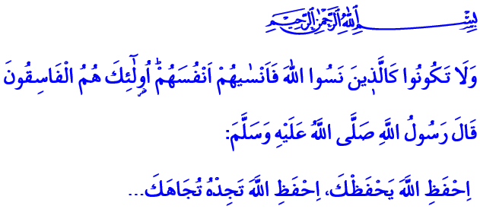

THOSE WHO FORGET ALLAH
WILL BE FORGOTTEN
Honorable Brothers and Sisters!
Our Prophet (pbuh) took on a journey with his cousin Abdullah. On this journey, he said “My dear child! I’ll give you some advice. Do not forget them!” Then he gave this advice to this young companion about how he shouldn’t break his connection with the Lord: “Be mindful of Allah and He will protect you. Be mindful of Allah and you will find Him before you. When you ask, ask Allah, and when you seek aid, seek Allah's aid. Know that if the entire creation were to gather together to do something to benefit you- you would never get any benefit except that Allah had written for you. And if they were to gather to do something to harm you- you would never be harmed except that Allah had written for you.”
Honorable Believers!
We are all human. Sometimes we forget our neighbors, our family and our friends in this busy life. Sometimes we forget our relatives, our brothers, the orphans and the needy. Sometimes we forget about ourselves, our society, and our responsibilities. But besides all this, the worst thing for a person is to forget the purpose and reason of his creation. The real defeat is leading a life where you forget your Lord; it is to disregard your oath of servitude, your agreement with Allah; it is to ignore the scale, the judgement and the afterlife, forgetting the fact that this world is mortal. Therefore our Lord warns us not to be among those who forget Him: 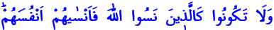 “And be not like those who forgot Allah, and He caused them to forget their ownselves.” 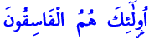Those are the Fasiqun (rebellious, disobedient to Allah).”
Honorable Brothers and Sisters!
Our Lord sent us the Quran to teach us our duties and responsibilities. Another name of our Holy Book is Dhikr Al-Hakim (reminder of wisdom). It is a book that reminds us the things we should not forget. It is a lamp, a guide that illuminates our path. Let us hold fast to it and open our hearts, our minds and our lives to it.
Our Lord enjoined: “You are only a one who reminds” and sent a Prophet with the most beautiful character to the believers to show the true path and to remind Him to them. He blessed us with Muhammad Mustafa (pbuh.). He taught us what is right and true, wrong and false, good and bad. Let us live by his sunnah; do not stray from his exemplary life and bless our life with his messages of mercy.
Our prayers, sacrifice, pilgrimage, zakat, fasting, in short all of the rituals of worship are prescribed for us so that we could always remember our Lord. Let us not forget that our worship brings us closer to our Lord and makes us more honorable on the sight of Him.
Dear Brothers and Sisters!
Those who lead a life where they forget Allah will be forgotten by Him in this world and in the afterlife. Allah will deprive those who are ungrateful to Him in this world from His mercy in the great day. On the Day of Resurrection, where there is no sanctuary other than the mercy of Allah, those who became a slave to this world will hear this: “This Day We will forget you as you forgot the Meeting of this Day of yours. And your abode is the fire, and there is none to help you.”
Brothers and Sisters!
Please come! Let us not forget our responsibilities to our Lord, our family and our society in this short life. Let us not forget that it is our duty to live in accordance with Allah’s will. Let's keep in our minds that the goal of our existence is to prepare for that great day. Let us not neglect our prayers as they are our expression of thanks to our Lord’s blessings. Let us live with the consciousness that in every moment He could see us, know about every one of our actions and hear every word coming out of our mouths. Let us not forget that eternal peace comes through a life that is lived on the path of Allah's will.
Brothers and Sisters!
I conclude this khutba with these prayers that our Lord taught us in the Quran:
“Our Lord! Condemn us not if we forget or fall into error!”
“Our Lord! Let not our hearts deviate (from the truth) after You have guided us, and grant us mercy from You. Truly, You are the Bestower.”
“Our Lord! Forgive us our sins, and remit from us our evil deeds, and make us die the death of the righteous! Our Lord! Grant us what You promised unto us through Your Messengers and disgrace us not on the Day of Resurrection, for You never break (Your) Promise.”

Tirmizî, Chapters on the description of the Day of Judgement, Ar-Riqaq, and Al-Wara', 59.
Al-Hashr, 59/19.
Al-Ghashiyah, 88/21.
Al-Jathiyah, 45/34.
Al-Baqarah, 2/286.
Ali ‘Imran, 3/8.
Ali ‘Imran, 3/193-194. Written by: General Directorate of Religious Services

