DATE: April 27th, 2018
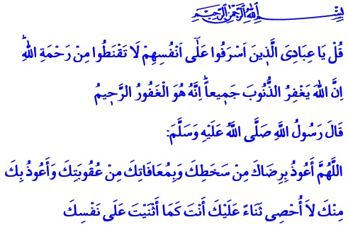
BARA’AH NIGHT – AN OCCASION FOR FORGIVENESS, PURIFICATION AND SALVATION
Jumu’ah Mubarak, Esteemed Believers!
Our Almighty Lord with His infinite mercy and unlimited forgiveness gives us this glad tiding in the verse I recited, “Say, ‘O My servants who have transgressed against themselves [by sinning], do not despair of the mercy of Allah. Indeed, Allah forgives all sins. Indeed, it is He who is the Forgiving, the Merciful.’”
Honorable Muslims!
We are rejoicing in approaching the Bara’ah Night, an occasion for forgiveness, purification and salvation. Eternal praise be to our Almighty Lord. Inshallah, we will altogether attain the bounties of the Bara’a Night, on April 30th, the night that connects Monday to Tuesday.
In a hadith qudsi, our Prophet (s.a.w.) said: “Spend the fifteenth day of the month of Shaban by observing a fast and its night in prayer. Because, when the sun sets at that night, Allah Ta’ala manifests Himself at the nearest heaven in a state which we cannot know of, and until the time of dawn He says, ‘Is there nobody asking for forgiveness? Forgive I shall! Is there nobody asking for sustenance? Sustenance I shall give him! Is there nobody suffering a calamity? Felicity I shall give him! …”2
Brothers and Sisters!
Life is our most precious wealth. Each hour is worth a treasure, each minute is worth riches. The Bara’ah Night is one of the most blessed stops on our journey of life. The Bara’ah is a night of opportunity for us to review our existence, granting us the chance for contemplation and consideration. The Bara’ah is forgiveness. It is the day when the Divine Mercy manifests itself. The Bara’ah is time for remorse and hope. The Bara’ah is the night when hands are raised for dua, and hearts are opened to the heaven. The Bara’ah means setting foot on the realm of mercy by turning towards our Lord.
The Bara’ah is the time of repairing broken hearts, collapsing the walls of resentment, and overcoming the feelings of grudge, hatred, and revenge. The Bara’ah is the night of salvation from the hold of our desires, fancies and whims, and redemption from the cravings of our nafs. It is the time of alertness against the wiles and decoys of the nafs, and of the Devil.
Dear Believers!
The Bara’ah Night teaches us every year to keep away from all kinds of evil, oppression, wrongdoing and injustice. The Bara’ah Night reminds us of not only reaching Allah’s forgiveness, but also of being forgiving. For those who expect forgiveness from Allah also become forgiving. They become forgiving and tolerant towards themselves, their families, their brothers and sisters in religion, their surroundings, and the entire universe. Those who seek Allah’s content cannot despise or denigrate anybody. Those who seek to reach the love of Allah always bear love and mercy in their hearts.
Honorable Believers!
With the occasion of this night, I would like to once again remind that we all have responsibilities individually on the way to “become a beneficial ummah for all humanity” as it is not possible to be good believers by being indifferent to what is going on around us.
Let us, in this blessed time, recall the responsibilities we have forgotten and abandoned. If we have become of people who chose this world over the Hereafter, let us repent for love and compassion we refrained to show even to our nearest. If we have left orphans, our oppressed brothers and sisters alone, let us repent. Let us review our servitude to Allah if we have omitted it. Let us crown our worn-out hearts with dua, worship and contemplation. Let us block the roads that lead to sins and evil. Let us strive for a world where goodness rules. Let us put to good use these days when Allah’s compassion manifests in abundance. Let us submit our repentance and contrition only to Him with our obedience, devotion, and good deeds. Let us turn away from our faults, wites, and sins, not to return again.
I would like to conclude this khutbah with the following dua of our Prophet (s.a.w.), “O Allah! I take refuge in your content from your wrath, I take refuge in your forgiveness from your punishment, I take refuge in You from You. I cannot finish counting praises for you. You are as You have praised Yourself.”
“O Allah! Help us in remembering You, in expressing our gratitude for Your bounties, and in worshiping You in the most beautiful form.”

Zumar, 39/53.
Ibn Majah, Iqamat al-Salat, 191. 3 Muslim, Salat, 222.
4 Abu Dawud, Witr, 26. Directorate General of Religious Services

